USER-GUIDE for COVID-19 WORKFORCE SURGE PLANNING TOOLS – RAPID AND REMOTE COVID WORKFORCE ASSESSMENT

November 2020

CONTENTS
Acknowledgements 5
Definitions 6
Terms 6
Abbreviations 7
Executive summary 8
Summary 8
Overview 8
Introduction 10
Before you begin 11
Step 1. Assemble your data 14
Define your region of interest 14
Define your staff categories 14
Begin to assemble your data collection sheets 14
Step 2. Review your data 28
Continue your data collection sheets 28
Document and check your assumptions 28
Step 3. Populate the tools 29
Adaptt Surge Planning Support Tool 29
HWFE 39
Contact tracing 48
Introduction 48
Use of digital tools 49
Using the tool 49
Contact Tracing tab 50
Forward Planner tab 52
Parameters tab 52
Calculations tab 56
Data tab 57
Step 4. Scale your results 58
References 59
Annex 1. Template data collection sheets 60
Professional Activities Data Collection Sheet 60
Staffing Data Collection Sheet 61
Available Working Time 61
Facility Data Collection Sheets 62
COVID-19 Daily Reported Data 62
Role Substitution Data Collection Sheets (optional) 63
Midnight Census (optional) 64
Annex 2. Time required per 24-hour day for professional activities by cadre and level of severity 65
HWFE Mild Patient Needs 65
HWFE Moderate Patient Needs 66
HWFE Severe Patient Needs 67
HWFE Critical Patient Needs 68

Acknowledgements
The Covid-19 workforce surge planning tools – rapid and remote COVID workforce assessment – a user guide was developed for the WHO Regional Office for Europe by IntraHealth International, Cris Scotter (WHO Regional Office for Europe), Alexandre Lourenco (Associação Portuguesa de Administradores Hospitalares) and Graham Willis (independent contractor).
It supports implementation of the WHO surge planning tools developed to assist Member States of the WHO European Region to assess the impact of COVID-19 on human resources for health. This project was led by Cris Scotter, supported by Pryanka Relan and Teresa Kortz (WHO headquarters). The Adaptt Surge Planning Support Tool software was developed by Alexandre Lourenco and Ricardo Gil Santos, Steeve Ferreira and Liliane Costa (Glintt), and the Health workforce estimator Tool and Contact Tracing software were developed by Graham Willis for the WHO Regional Office for Europe with the assistance of Sion Cave (Decision Analysis Services Ltd).
The user guide was prepared by the following IntraHealth International, Inc. staff: Pamela A. McQuide, Global Healthcare workforce Technical Advisor; Amy Finnegan, Data Scientist; Andrew Brown, Senior Director, Healthcare workforce Development; and Katherine Terry, Nurse Practitioner, IntraHealth Nursing Now Fellow.

WHO wishes to thank Dave Potenziani, Information Technology Advisor from IntraHealth, Inc. for his support. WHO also thanks Alexandre Lourenco and Graham Willis for their technological expertise in developing the Adaptt and Health workforce estimator tools.
The hope is that Member States of the WHO European Region and other users will find the user guide helpful in supporting implementation of the tools during this unprecedented global COVID-19 crisis.

Definitions

Terms
The Adaptt Surge Planning Support Tool was developed by the WHO Regional Office for Europe and allows for visualization of needs during a surge, including the number of hospital beds and human resources required, dates of predicted shortages, contact tracing and home-care needs.
An attack rate refers to the estimated percentage of the population that is expected to contract the disease during a specified time period.
Available working time is the number of hours or days that a health worker is available to work, taking holidays, sick days and other absences into account.

The Contact Tracing Tool (CTT) was developed by the WHO Regional Office for Europe and is used to estimate the staff required to track and trace confirmed COVID-19 cases, with the aim of preventing onward transmission.
The Health workforce estimator (HWFE) was developed by the WHO Regional Office for Europe and is used to estimate the number of each cadre of health worker needed based on the number of mild, moderate, severe and critical patients per day. It also highlights workforce gaps so that countries can plan for projected shortages.
Horizontal substitution refers to the process of using work groups who are not currently in the Healthcare workforce to substitute for current roles. This may be necessary to meet workforce needs during a surge. For example, a recently retired nurse can be substituted into the role of a nurse.
A midnight census is a tool that captures the number and severity of patients who are in the hospital at a specific point in time each day. It should show the number of people who have been admitted into or discharged from the hospital in the previous 24 hours, the number of deaths and the current number of people hospitalized, by severity.
Vertical substitution refers to the process of upskilling or repurposing current work groups to assist other cadres. This may be necessary to meet workforce needs during a surge. For example, a ward nurse may use part of his/her time to assist a critical care nurse, which would then allow the critical care nurse to use his/her training to care for more patients.
Workload Indicators of Staffing Need (WISN) is a tool that uses service statistics to assess staff workloads and estimate human resource needs according to professional standards. It is used in many countries to assess health worker needs by cadre.

Abbreviations
ECMO extracorporeal membrane oxygenation
HCW health worker
HRH human resources for health
ICU intensive care unit
SIR susceptible, infected and recovered (models)

Introduction
The coronavirus pandemic and COVID-19 has impacted the entire world. As it continues to spread it has pressing implications for health workers and Healthcare workforce staffing, particularly in low- and middle-income countries, which will need to rapidly increase their preparedness, readiness and response to the pandemic (Bong et al., 2020).
Health workers (HCWs) – nurses, midwives, community health workers, doctors, pharmacists and other cadres who provide care directly to their communities – play a critical role during disease outbreaks. They are the backbone of a country’s defences to limit or contain the spread of disease, testing and treating patients while providing key community messaging regarding how to respond to the disease. In these pandemic settings, governments need to ensure that HCWs are available, sufficiently well trained and supported to perform their jobs safely, and meet the surge in demand for services due to the pandemic, while safeguarding the availability of other essential health services.
In addition to COVID-19 responses, HCWs are required to continue providing other essential services, including maternal and child health, HIV/AIDS, malaria, tuberculosis and voluntary family planning services. The Healthcare workforce is also affected by school closures, which puts tremendous strain on families because most health workers are women (Wenham et al., 2020).
Ministries of health and human resources for health (HRH) departments within them need access to a rapid and responsive Healthcare workforce deployment plan to secure HCW availability and distribution to ensure ongoing front-line health services.
WHO has created three tools to meet this need. The Adaptt Surge Planning Support Tool allows for visualization of needs during a surge, including the number of hospital beds required, dates of predicted bed shortages and human resource needs (WHO Regional Office for Europe, 2020a). The Health workforce estimator (HWFE) is used to estimate the number of each cadre of health worker needed based on the number of mild, moderate, severe and critical patients per day, demonstrating workforce gaps so countries can plan for projected shortages (WHO Regional Office for Europe, 2020b). The Contact Tracing Tool (CTT) is used to calculate the staff required to support the process of identifying, assessing and managing people who have been exposed to the disease to prevent onward transmission.
This Rapid and Remote COVID Workforce Assessment implementation user guide for predicting COVID-19 Healthcare workforce staffing needs has been developed to serve as a guide for implementing WHO’s Adaptt, HCWFE and CTT tools, adjusted to countries’ cadres and available services to prepare for pandemic surges.
The user guide was developed remotely from experience with two pilot programmes conducted by IntraHealth International, Inc. in Kenya and Mali. Although it provides a roadmap for the process, implementation will look different in various places, and flexibility will be required to implement the approach successfully. It is important to read through and understand the toolkit before beginning the implementation process. Included in the toolkit are the lessons learned from the pilot programmes so that applicable steps can be followed for other situations.

Overview
The toolkit is designed to be implemented in four steps over a six-week period. Implementing partners include in-country office experts, with technical support from IntraHealth International, Inc. office in Chapel Hill, North Carolina, United States of America. The toolkit is summarized in Table ES.1.
Table ES.1. Toolkit summary
 | Activity | Timeline
 | Activity | Week 1 | Week 2 | Week 3 | Week 4 | Week 5 | Week 6
Before you begin | Engage key stakeholders
Before you begin | Assemble your team
Step 1 | Define region of interest | X
Step 1 | Define health-worker categories | X
Step 1 | Assemble essential data collection sheets:  - Professional Activities Data Collection Sheet  - Available Working Time  - Staffing Data Collection Sheet  - COVID-19 Daily Reported Data  - Facility Data Collection Sheet  Assemble optional data collection sheets:  - Role Substitution Data Collection Sheet  - Midnight Census |  | X  X  X  X  X  X  X | X  X  X  X  X  X  X | X  X | X  X | X  X
Step 2 | Review data collection sheets to ensure they reflect local realities |  |  | X | X | X | X
Step 3 | Populate Adaptt, HWFE and CTT |  |  |  | X | X | X
Step 3 | Check the modelled tools, validate assumptions |  |  |  | X | X | X
Step 4 | Scale results to rest of country |  |  |  |  |  | X

Before you begin

Assemble your team
Implementing a rapid and remote COVID workforce assessment successfully requires a team-based approach. The following roles are recommended at a minimum for successful implementation, and we recommend that the team on the ground mirrors the remote team with the roles shown in Table 1.
Table 1. Team roles
Role | Functions | Characteristics
Project manager/team leader | Oversees the team, leads the initiative, plans the details of implementation, monitors progress, and reports outcomes  Obtains agreement from key stakeholders, approval from government and ministry of health
Epidemiologist/data scientist | Monitors and tracks the epidemic, gathering daily statistics on the trajectory of the infection  Uses the data to populate the Adaptt and HWFE tools, documents assumptions made for calculations | Should be comfortable with statistics, have experience analysing data, and extensive knowledge of Excel  Familiarity with susceptible, infected and recovered (SIR) models would also be helpful
Healthcare workforce/human resources focal point | Obtains existing Healthcare workforce data, assists with completing professional activities | Should be familiar with the iHRIS Healthcare workforce Information Systems Software or other human resources databases, District Health Information Software 2 (DHIS2) or another Healthcare workforce database
Health systems focal point | Reports on hospital systems, obtains data from local hospitals, assists with completing professional activities | Should be a clinician or public health practitioner who understands the health systems and health worker cadres
Country leader | Obtains permission to acquire and use data Ensures that WHO and other stakeholders are involved in the process | May be a representative from the ministry of health or WHO country office
Local WHO focal point |  | In-country and/or regional WHO representative

In addition to the in-country team roles listed in Table 1, the remote office will offer technical support to review assumptions and ensure that the tools are implemented correctly.

Understand the data
Before implementing the Adaptt and HWFE tools, your team will need to complete the following data collection forms. With these forms, you will be able to supply the appropriate data for the tools. We suggest using the forms to collect the data first and then input them into the tool so that the team can use one version of the tool, since some of the data needs to be reshaped to fit into the tools.

Essential data collection sheets
A brief description of the essential data collection sheets required to complete the WHO tools is provided below. Details on each of the forms are provided in Step 1, and blank templates can be found in Annex 1.
- Professional Activities Data Collection Sheet: this form collects information about the key activities to care for COVID-19 patients by cadre and level of severity and the average time it takes to perform these activities per patient per 24 hours. The WHO professional activities for Europe are found in Annex 2. It will be helpful to compare your standards to those developed by WHO so you capture the essential service delivery activities.
- Available Working Time: this form collects information about the number of days and hours the average staff person of a specific cadre works in one year.
- Staffing Data Collection Sheet: this form collects Healthcare workforce data per cadre per facility by level of severity.
- COVID-19 Daily Reported Data: this form requires daily COVID-19 case data to be inputted, including confirmed new cases, total number of confirmed cases and suspected cases. The data should be specific to the area in which you are working. For example, if you are working in the region of Mombasa, you should use Mombasa data for the tool, not data from all of Kenya.
- Facility Data Collection Sheet: this form tracks facility resources, including the total number of beds available, number of beds allocated to COVID-19, intensive care unit (ICU) beds and mechanical ventilators. If your facility also does extracorporeal membrane oxygenation (ECMO) and renal dialysis, those data are also collected.

Optional data collection sheets
A brief description of the optional data collection sheets is provided below. Details on the forms are provided in Step 1, and blank templates can be found in Annex 1.
- Role Substitution Data Collection Sheet: this form collects information on utilizing new sources of health workers who can substitute with existing health worker roles to increase health worker capacity during a surge.
- Midnight Census: this form requires daily hospitalization data for the target facilities, including the number of admissions, discharges, deaths and number of cases currently hospitalized that day by level of severity. These data allow the user to compare the model with what is happening on the ground, and may be especially useful for facility managers.

Data collection checklist
With access to the completed data collection sheets, you will be able to complete the Adaptt and HWFE tools. A suggested checklist is provided in Table 2 to assist your team with collecting the appropriate data.

Table 2. Data collection checklist
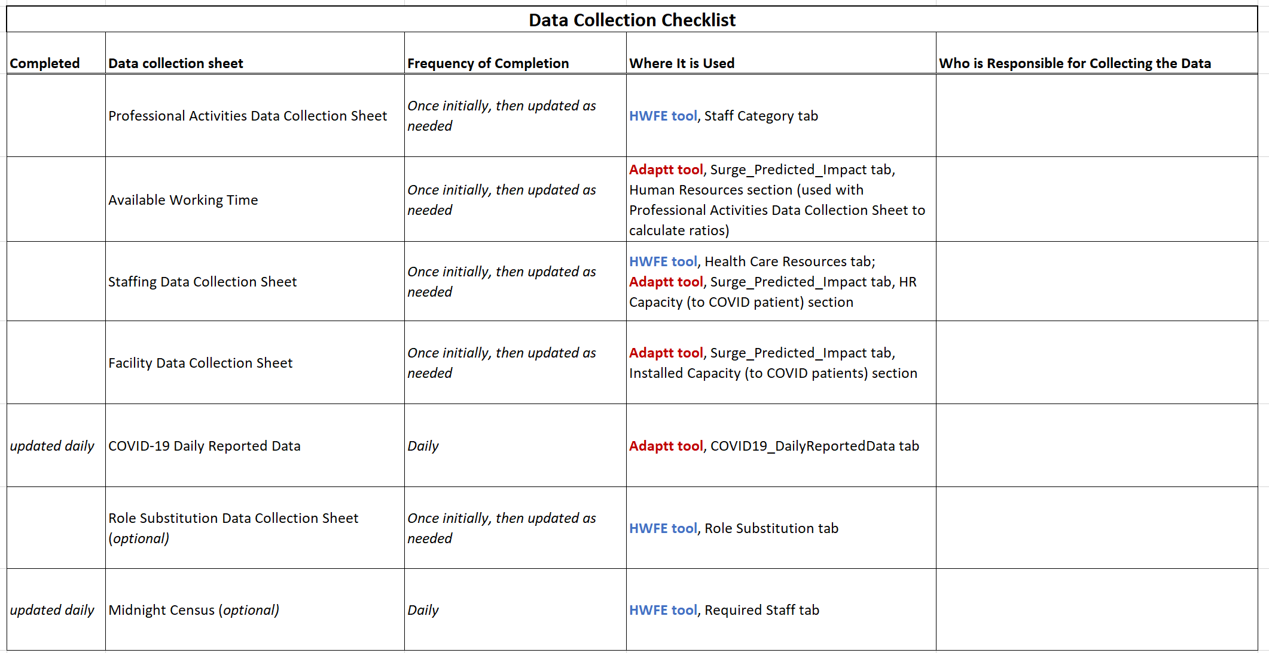
Note: this checklist may be helpful when assigning tasks to your team members. It is important to assign the data collection sheets to team members with the appropriate experience.

Step 1. Assemble your data

Define your region of interest
Initially your team will need to decide where to begin.
It is recommended to start with one region or facility before implementing the tools throughout the country. This will allow you to understand the data needed, how to customize the tools to the local context and ways to adapt the tools to fit your needs. It will also allow you to see the epidemic spread; as the infection becomes more prevalent, you can scale the approach to look at implications down the road. We suggest selecting a region in conjunction with the ministry of health that has available data and experienced partners. After you have successfully implemented the tool in your first selected region, you can then scale it countrywide.

Define your staff categories
Your team will then need to define the staff categories of interest who will be caring for patients with COVID-19. This may include general physicians, specialist physicians, general ward nurses, critical care nurses, facility cleaners, social workers and laboratory and respiratory technicians.

Begin to assemble your data collection sheets
When to use the data collection sheets versus the Adaptt tool and HWFE
The data collection sheets are designed to be updated as needed by pertinent team members. They should be stored on a shared drive folder so team members may update the same version of the sheet.
However, it is strongly encouraged to keep the Adaptt and HWFE tools locked by one or two users so they are updated by the same person. This will reduce the possibility of errors being introduced.
Your team can then begin to gather the data needed for the data collection sheets, beginning with the following data sheets. There are five essential data collection sheets that are necessary for populating the Adaptt and HWFE tools, and two optional data collection sheets that provide additional helpful data. Don’t worry if you don’t have all the necessary data available when you begin populating these tools. If certain data are not available, you may choose to estimate the data using the assumptions or proxies provided. Be sure to record any assumptions made.
Listed below are the data collection sheets, accompanied with sample data and explanations. As you begin to fill in the data collection sheets, make a note of data gaps and consider appropriate assumptions or estimations that could be made to fill those gaps.

Professional Activities Data Collection Sheet
- What is this form and how will it be used?
  - Professional activities identify the amount of time it takes for a skilled professional of a specific cadre to perform certain tasks to professional standards. They may vary from country to country depending on local contexts.
  - When developing your local professional activities, you may review the professional activities for mild, moderate, severe and critical patients with COVID-19 that are listed in the Reference tabs of the HWFE (see Annex 2 for examples of professional activities for patients in a European context). It is important to review these professional activities sheets, but you will need to adapt them and use only the activities that are pertinent to your country so they are appropriate and relevant to your country context.
  - In Step 3, you will use the Professional Activities Data Collection Sheet to fill out the Staff Category tab in the HWFE.
- Who will populate this form?
  - The Healthcare workforce/human resources expert, health systems expert and/or country leader will populate the form.
- How will the data be obtained?
    - If your country has implemented WISN, it is recommended that you review your WISN activity standards for hospitalized patients and compare them to those provided in the Reference tabs of the HWFE. The HWFE activities were developed for the European context, so you will need to remove any activities that are not performed in your context and estimate the amount of time per activity to reflect the local context.
Workload Indicators of Staffing Need (WISN)
WISN is a tool that uses service statistics to assess staff workloads and estimate human resource needs according to professional standards. It is used in many countries to assess health worker needs by cadre.
    - If your country has not implemented WISN, it is recommended that you review the professional activities provided in the Reference tabs of the HWFE by level of severity, also provided in Annex 2 in the toolkit. It is important to review these professional activities, but you will need to adapt them to fit your local context. For example, if you do not provide ECMO in your local context, you will need to remove that activity. You will then need to consult with local health workers per cadre, in addition to relying on personal experience, to calculate the number of hours per day that a health worker spends with one COVID-positive patient in a 24-hour period per level of severity. As you are filling out this form it is important to document any assumptions made.
- How to calculate the data?
    - If your country has implemented WISN, it will be helpful to compare the provided reference sheets with local activity standards your country has already completed from a previous WISN study. It may be sufficient to compare the provided activity standards/professional activities with local activity standards and adjust the times appropriately. In this case, you may simply transfer the occupational titles and update the time per patient. In Kenya, we inflated the activity standards by 6% based on the WISN conducted there as part of a previous HRH programme.
    - If your country has not implemented WISN, you may estimate your professional activities by reviewing activities per cadre from the tabs in the tool – Mild Patient Needs, Moderate Patient Needs, Severe Patient Needs, Critical Patient Needs – and then calculate the number of hours per day that a specific health worker cadre spends with one COVID-positive patient in a 24-hour period per level of severity. This 24-hour period will include multiple shifts, so it is important to consider the 24-hour time period rather than professional activities per shift. In addition to direct medical care, make sure to consider non-medical activities, such as patient teaching, bathing and assisting critical patients with toileting.
    - For example, let’s calculate the professional activities for a nurse caring for a patient who is critically ill. First you will review the reference sheets and consider all activities that the nurse may perform in your country context. After considering each activity performed over each of the three eight-hour shifts in a 24-hour period, you may find that it will take 3.5 hours per shift or 10.5 hours/24-hour period.
- What should I do if the same duties are shared by different cadres?
  - If duties are shared by different cadres, then you may need to apply a ratio to obtain these values.
  - For example, let’s say that a medical practitioner spends three hours per 24-hour period with one critical patient. However, the critical care unit is staffed with both a specialist medical practitioner (critical care) and a medical practitioner (general). If the specialist medical practitioner (critical care) cares for 80% of the critical care patients, and the medical practitioner (general) assists in the care of the other 20%, you may apply a ratio to determine the amount of time that each medical practitioner spends with a critical patient. In this example, the time per patient per 24 hours for the specialist medical practitioner (critical care) is 2.4 (three hours multiplied by 0.8), and the time per patient per 24 hours for the medical practitioner (general) is 0.6 (three hours multiplied by 0.2) (see Fig. 1 for a visualization of these calculations in the data collection sheet).
Fig. 1. Sample professional activities sheet
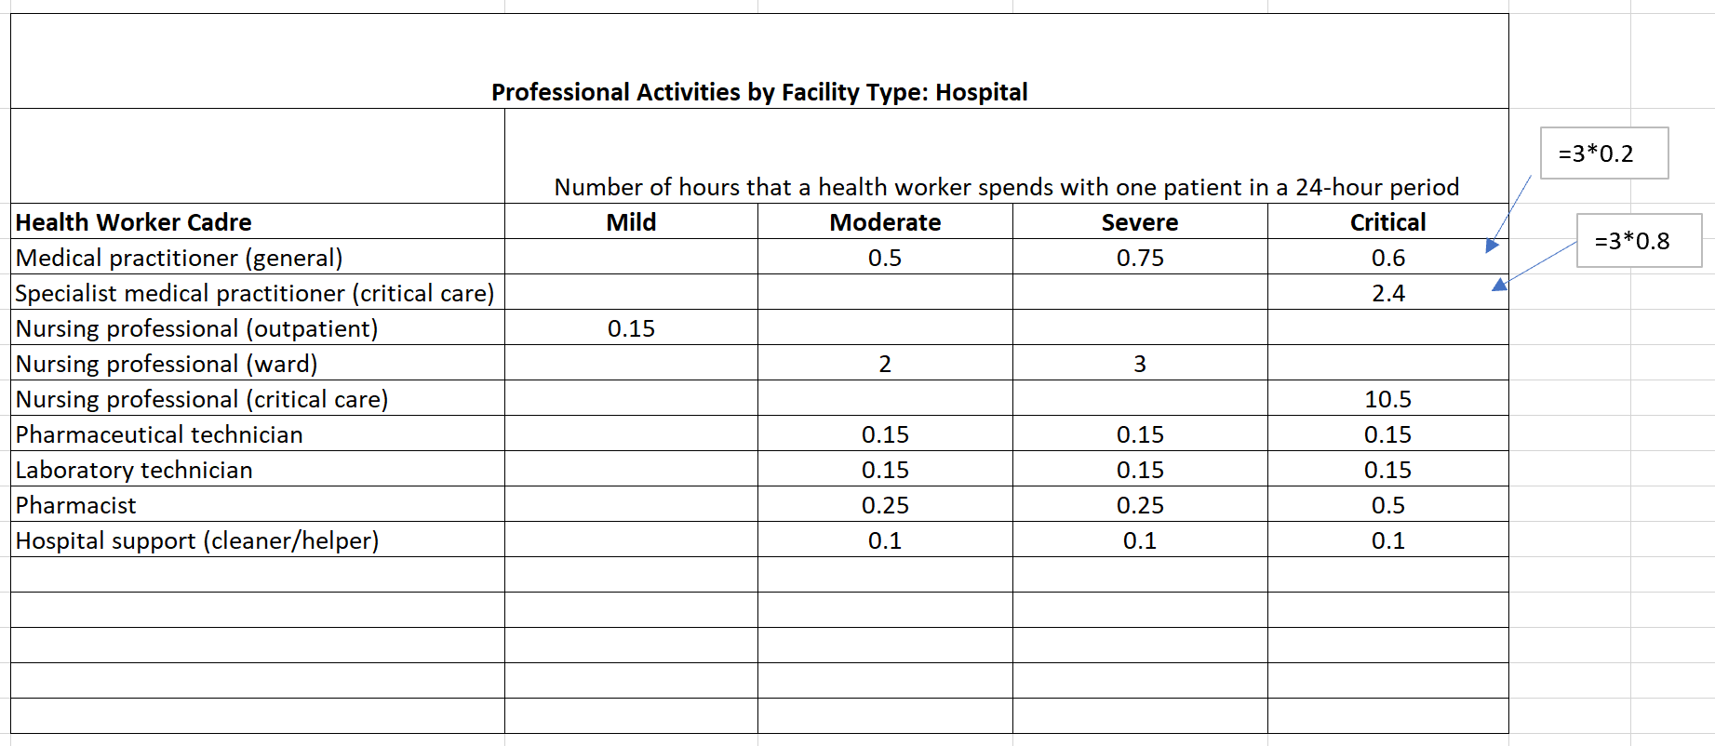
Note: the Professional Activities Sheet displays how many hours a health worker spends with one patient in a 24-hour period by severity. These values may be obtained from WISN data or by estimating the amount of time per patient based on professional standards. It is important to consider the professional activities of a health worker for each patient by level of severity. Fig. 1 also includes an example of how to calculate the professional activities for staff categories who may share the same duties, such as the medical practitioner (general) who cares for 20% of critical patients and the specialist medical practitioner (critical care) who cares for 80%. As you are filling out this form, it is important to document any assumptions or estimations that are made.

Available Working Time
- What is this form and how will it be used?
  - Available working time is the number of hours or days that a health worker is available to work, taking holidays, sick days and other absences into account (see a sample sheet in Fig. 2).
  - In Step 3 this form will be used in conjunction with the Professional Activities Data Collection Sheet to calculate the ratio of staff to patients that will go into the Adaptt Tool, Surge_Predicted_Impact tab, Human Resources section.
- Who will populate this form?
  - The Healthcare workforce/human resources expert, health systems expert and/or country leader will populate the form.
- How will the data be obtained?
    - If your country has implemented WISN, the team will need to access WISN data to obtain staff category working times per region.
    - If your country has not implemented WISN, you may obtain these data by consulting local human resource experts at the facilities.
- How do I calculate the estimates in the worksheet?
  - Staff category: these roles should be listed according to the categories of interest determined by your team.
  - Working days per week: if your staff work a 40-hour work week, you should keep this value at five, even if some staff work do not work their 40 hours in five days.
  - Hours per working day: if your staff work a 40-hour work week, you should keep this value at eight even if some staff work more or fewer than eight hours per day but total 40 hours per week.
  - Annual leave: this is the amount of annual leave staff are allowed, even if they do not choose to take their entire annual leave.
  - Public holidays: the number of public holidays available to staff in addition to annual leave.
  - Sick leave: this should be the average number of hours that people take per year for sick leave. You likely will not have precise data for average amounts of sick leave, but you can estimate the average number of days that a person was unable to work due to illness in the past year. You may choose to include maternity and paternity leave.
  - Unplanned absences: this includes absences for unplanned reasons, such as attending a funeral or other unexpected event.
  - Training days: this refers to the number of days that a staff member will not be available to work at the facility due to training events such as continuous professional development training. This does not include in-service training or extended study leave.
  - Total non-working days per year: this is the sum of all the days a person does not work during the expected work week, including annual leave, public holidays, sick leave, unplanned absences and training days.
    - For example, the total non-working days per year for a medical practitioner (general) = 20 + 12+ 5 +2 +5 = 44.
  - Working days per year: a person who works five days per week and eight hours per day with no absences will work 260 days. To calculate working days per year, you should subtract the total non-working days per year from 260.
    - For example, the working days per year of a medical practitioner (general) = 260 – 44 = 216.
  - Working weeks per year: you may calculate working weeks per year by dividing the number of working days per year by five days/week.
    - For example, the working weeks per year of a medical practitioner (general) = 216/5 = 43.2.
  - Working hours per year: you will calculate working hours per year by multiplying the working days per year by eight hours per day = 216*8 = 1728.
Fig. 2. Sample Available Working Time Collection Sheet
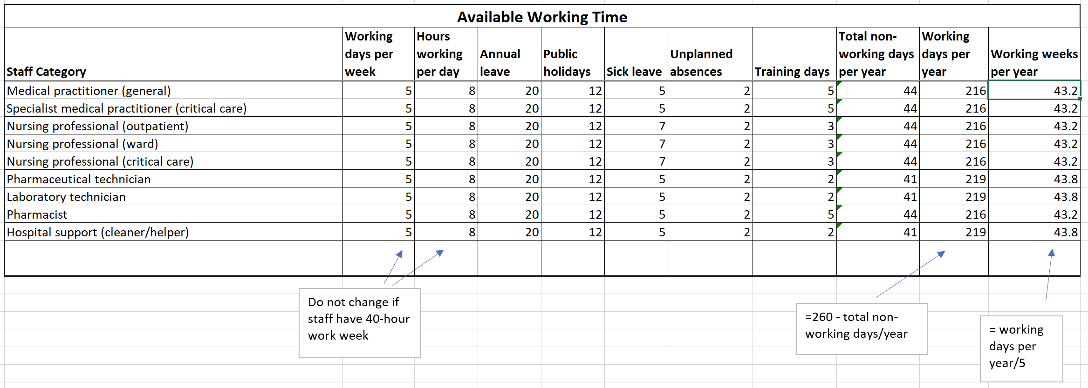
Note: this form demonstrates the number of days that a health worker is available to work in a year, taking into account planned and unplanned absences. It will be used to calculate staff-to-patient ratios. As you are filling out this form, it is important to document any assumptions or estimations that are made.

Staffing Data Collection Sheet
- What is this form and how will it be used?
  - This form provides a visual of staff available for COVID-19 per facility by severity.
  - It will be used in Step 3 in the Adaptt Tool, Surge_Predicted_Impact tab, HR Capacity (to COVID patient) section, as well as in the HWFE Tool, Health Care Resources tab to calculate workforce needs during a surge.
- Who will populate this form?
  - The Healthcare workforce/human resources expert, health systems expert and/or country leader will populate this form.
- How will the data be obtained?
    - If your country uses HRIS, the team will need to access HRIS data to obtain staff numbers by facility. If possible, you should use the number of health workers employed per severity level.
    - If your country does not use HRIS, you may obtain these data by consulting local facilities to obtain the numbers of full-time staff employed per cadre and severity level.
- What should I do if I have access to the number of staff employed per cadre, but I don’t know how many staff are assigned to COVID-19?
  - If you cannot access data on how many staff are assigned to COVID-19, you will need to use a ratio to distribute the staff appropriately.
  - For example, Hospital A in Fig. 3 was able to provide the total number of staff per cadre, but they were not able to obtain the numbers of staff dedicated to patients with COVID-19. However, they shared that they had allocated approximately 25% of all their staff to patients with COVID-19. Using this information, it was possible to estimate the number of staff dedicated to COVID-19 by multiplying the total number of staff per cadre by 0.25 to obtain an estimated value. When creating an assumption, it is important to document the assumption so it can later be validated.
- What should I do if I have access to the number of staff employed per cadre, but I don’t know how many staff are assigned per severity level?
  - If you cannot access data on how many staff are assigned per severity level, you will need to access the number of staff assigned to COVID-19 cases, then calculate an estimate using the ratio of severity level of patients with COVID-19.
  - For example, in Fig. 3 we were able to estimate the number of staff dedicated to COVID-19 per cadre in Hospital A. We were unable to obtain number of staff by severity level, so it was necessary to use a ratio to estimate these values. Local data informed us that 5% of hospitalized COVID-19 cases were critical, 15% were severe and 80% were moderate. We know that critical care doctors and nurses care only for critical patients at this facility, so those numbers remained the same. The health systems expert on the team was able to obtain data on the distribution of pharmaceutical technicians, laboratory technicians and pharmacists by severity. This leaves us to make an estimate for medical practitioners (general), nursing professionals (ward), nursing professionals (critical care) and hospital support.
To make this estimate, let’s look at nursing professionals (ward). Ward nurses care only for moderate and severe patients, so we need to use a ratio to estimate how many ward nurses should be assigned to moderate and severe patients. If 95% of all patients are either moderate or severe, then we can use the ratio 95/100 = 0.8/x, which allows us to see that 84% of ward nurses will care for a moderate patient. Using the ratio 95/100 = 0.15/x, we can see that 16% of ward nurses will care for a severe patient. Of the 150 ward nurses who care for patients with COVID-19, 24 will be assigned to severe patients and 126 will be assigned to moderate patients.
Whenever assumptions are made, it is important to document the assumptions so they can be validated when comparing the tools with actual data.

Fig. 3. Staffing Data Collection Sheet
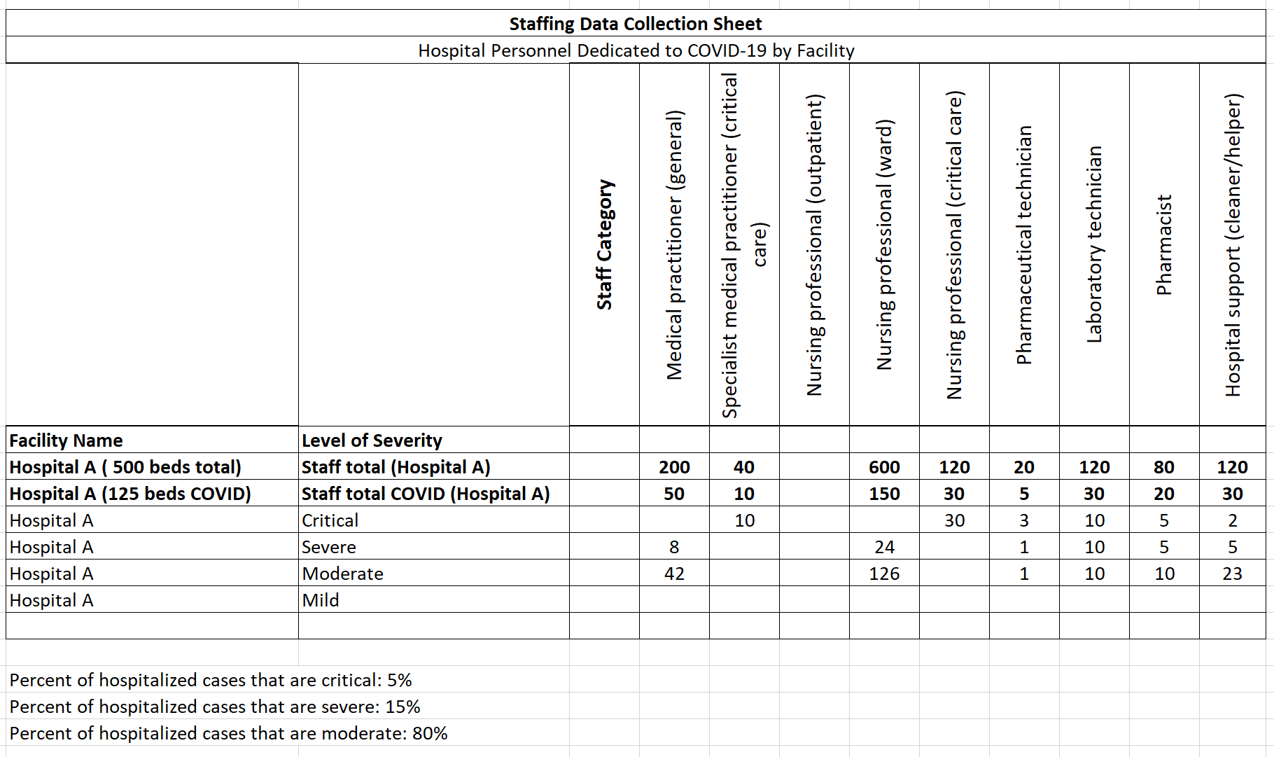
Note: this form depicts how many staff are available to treat patients with COVID-19 per facility, staff category and severity. It may be necessary to apply assumptions and estimates if not all data are available. In this example, we were able to obtain total number of beds, and the facility informed us that 25% of all beds were designated for patients with COVID-19. This allowed us to estimate number of beds and health workers for COVID-19. We also needed to estimate the distribution of medical practitioners (general), nursing professionals (ward) and hospital support (cleaner/helper) caring for COVID-19 patients by applying the ratio obtained from local data that 5% of hospitalized cases were critical, 15% were severe and 80% were moderate. Whenever assumptions are made, it is important to document them to validate the tools.

Facility Data Collection Sheet
- What is this form and how will it be used?
  - The Facility Data Collection Sheet provides a view of the bed capacity of the local health facilities in the region (Fig. 4).
  - This form will be used to populate the Adaptt tool so your country can see what the total bed capacity is for COVID-19 and can plan for anticipated bed shortages during the surge.
- Who will populate this form?
  - The Healthcare workforce/human resources expert, health systems expert and/or country leader will populate this form.
- How will the data be obtained?
  - The team will need to communicate with local health facilities to collect these data.
- How are each of the columns defined?
  - Region: specify the region of interest.
  - District: specify the district of interest.
  - Facility Name: name of health facility.
  - Type of Facility: please use categories specific to the country’s health system, such as main hospital, regional hospital, community health centre, etc.
  - Total Beds: this refers to the total number of beds available in the facility.
  - COVID-Designated Beds (Moderate): this is the number of beds designed to the care of patients with moderate cases of COVID-19.
  - COVID-Designed Beds (Severe): this is the number of beds designed to the care of patients with severe cases of COVID-19.
  - ICU Beds: this refers to the number of ICU beds dedicated to COVID-19.
  - Mechanical Ventilators: please specify how many mechanical ventilators are available in the facility.
Fig. 4. Sample Facility Data Collection Sheet
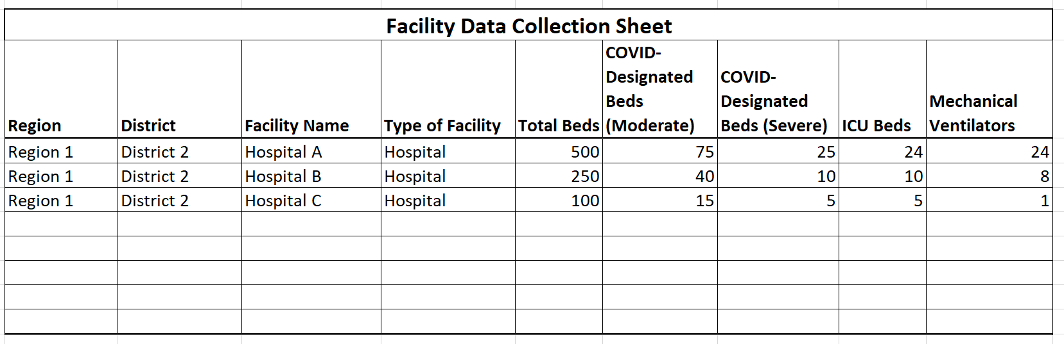
Note: this form allows you to see the bed capacity of local health facilities per region, as well as how many beds are designated to COVID by severity. As you are filling out this form, it is important to document any assumptions or estimations that are made.

COVID-19 Daily Reported Data
- What is this form and how will it be used?
  - This form tracks daily and cumulative cases of COVID-19 in the region of interest (Fig. 5).
  - It is used to populate the COVID19_DailyReportedData tab in the Adaptt tool.
- Who will populate this form?
  - The epidemiologist/data scientist, health systems expert and/or country leader will populate this form.
  - This form requires daily input of new confirmed cases and cumulative confirmed cases. Number of deaths is an optional data point that may be useful in your context.
- How will the data be obtained?
  - The team will need to communicate with local health facilities and government agencies to collect these data.
  - The data are specifically for the geographic location of interest, not the entire country.
- How are each of the columns defined?
  - Date: the data will need to be manually inputted daily.
  - Confirmed Cumulative: the cumulative number of cases in the region for that date.
  - Confirmed New: the newly confirmed number of cases in the region for that date.
  - Deaths: number of deaths for the date listed. You may choose to include deaths only for that day, or you may decide to document cumulative number of deaths, depending on which data are available for the region. Whichever data you decide to use, make sure they are consistent throughout the document.
- What do I do if I have total cases for the country, but not the geographic region?
  - It is likely that you may not have primary data available daily from the region of interest. In this case, you will need to decide how to determine the best daily estimate, and make sure to check these assumptions regularly to see if they have changed.
Fig. 5. Sample COVID-19 Daily Reported Data Collection Sheet
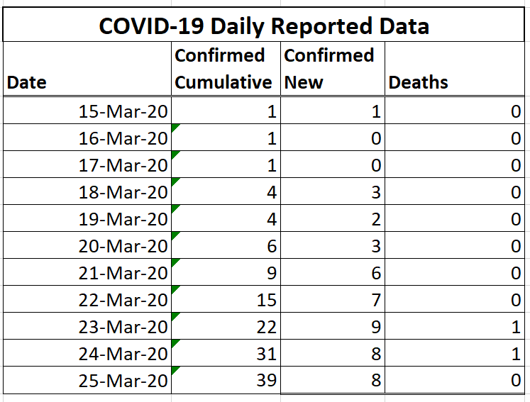
Note: this form captures the confirmed cumulative and new cases of, as well as deaths from, COVID-19 in your region of interest. These data should be specific to the geographic region you’re modelling and should be updated daily. As you are filling out this form, it is important to document any assumptions or estimations that are made.

Role Substitution Data Collection Sheet (optional tool)
- What is this form and how will it be used?
  - This form is used to define potential substitute work groups who can support the existing workforce during the surge, and how they can be utilized as support. Role substitution should only be considered once you have fully populated all other parts of the HWFE Tool and the results appear sensible.
  - Horizontal substitution refers to work groups who are not currently in the Healthcare workforce who may be used to substitute for current roles. For example, a recently retired nurse can be substituted into the role of a nurse.
  - Vertical substitution refers to how current work groups may be uptrained to assist other cadres. For example, a ward nurse may use part of his/her time to assist a critical care nurse, which would then allow the critical care nurse to use his/her training to care for more patients.
  - It is used to populate the Role Substitution tab in the HWFE.
- Who will populate this form?
  - The health systems expert, the Healthcare workforce/human resources expert and/or the country leader will populate this form.
- How will the data be obtained?
  - To complete the Horizontal Role Substitution Data Collection Sheet, you will need to consider potential workforce groups that can assist during a surge. This may include newly qualified doctors, newly qualified nurses, retired doctors and nurses, international doctors and contract cleaners. You will then need to consider which existing roles the substituting workforce may support. Finally, you will need to consider how many substitute health workers an existing health worker can supervise. In the example shown in Fig. 6, it was determined that 50% of newly qualified nurses could support outpatient nursing professionals, and that the other 50% of newly qualified nurses could support ward nursing professionals. It was also determined that one outpatient nursing professional could supervise two newly qualified nurses, and that one ward nursing professional could supervise two newly qualified nurses.
  - To complete the Vertical Role Substitution Data Collection Sheet, you will need to consider how you can use existing workforce groups to assist other cadres during a surge. You will need to consider which cadres are most vulnerable to shortages and consider what percentage of time another cadre may assist. Finally, you will need to consider how many substitute health workers the existing health worker can supervise. In the example shown in Fig. 7, it was determined that nursing professionals (ward) could spend 20% of their time assisting nursing professionals (critical care), and that each nursing professional (critical care) could supervise two nursing professionals (ward).

Fig. 6. Sample Horizontal Role Substitution Data Collection Sheet
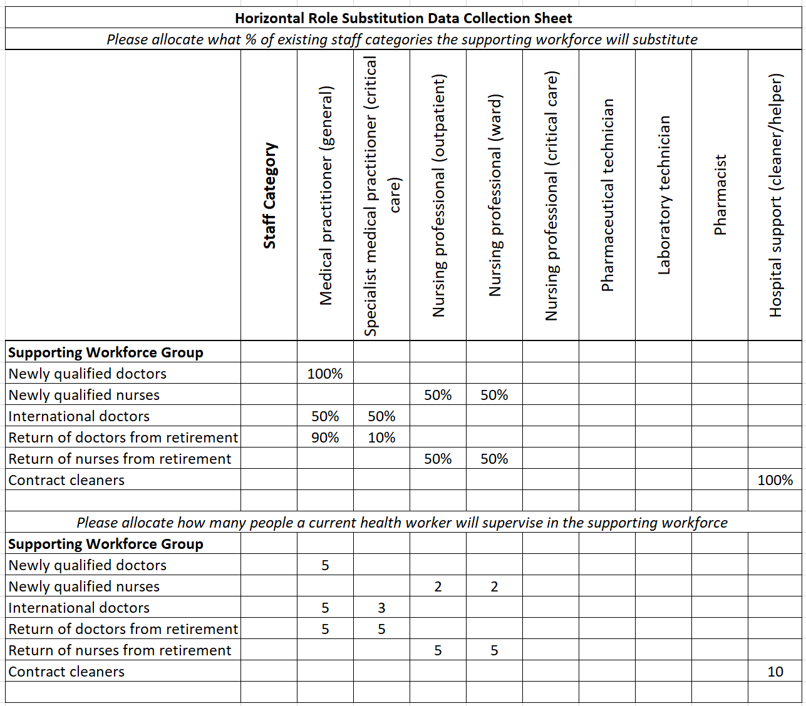
Note: the Horizontal Role Substitution Data Collection Sheet requires input of supporting workforce groups who may support the current workforce during a surge. You will need to determine which roles the supporting workforce groups will assist, as well as what percentage of the supporting workforce group will assist that cadre. You will then need to indicate how many supporting workers an existing staff member will supervise.

Fig. 7. Sample Vertical Role Substitution Data Collection Sheet
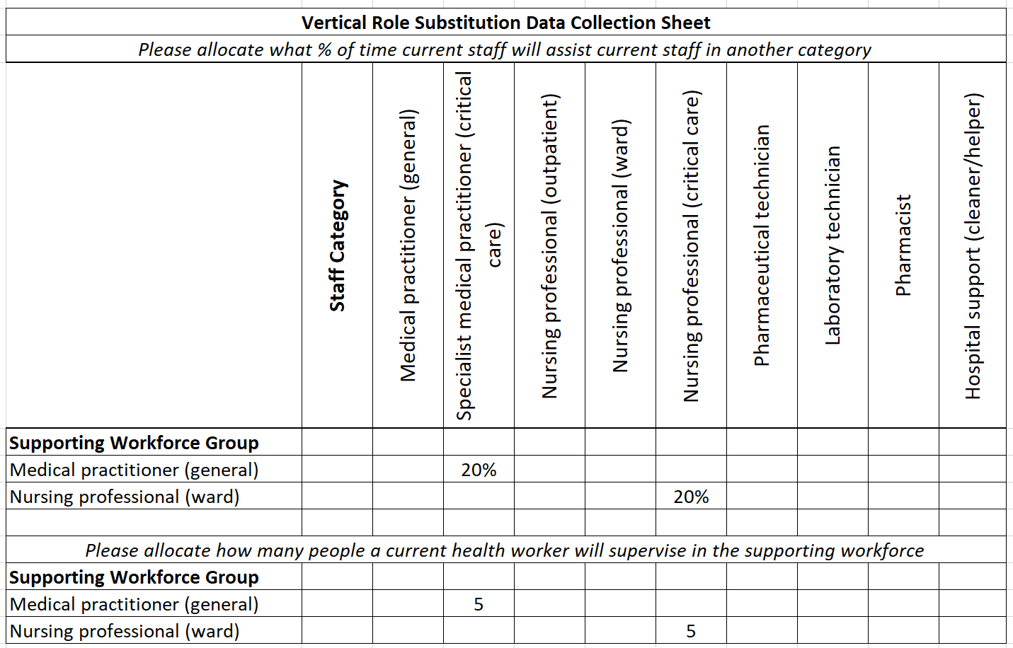
Note: the Vertical Role Substitution Data Collection Sheet considers how existing health workers can support other cadres during a surge. In this example, it was determined that medical practitioners (general) could spend 20% of their time assisting medical practitioners (critical care), and that each medical practitioner (critical care) could supervise three medical practitioners (general). It was also determined that nursing professionals (ward) could spend 20% of their time assisting nursing professionals (critical care), and that each nursing professional (critical care) could supervise two nursing professionals (ward).

Midnight Census (optional tool)
- What is this form and how will it be used?
  - The Midnight Census is meant to capture the number and severity of patients with COVID-19 who are in the hospital at a specific point in time each day (Fig. 8). It should show the number of people who have been admitted to, or discharged from, the hospital in the previous 24 hours, the number of deaths and the current number of people hospitalized, by severity. It requires daily input of data.
  - This suggested data collection form is optional, depending on the data that can be obtained in your local context. It may be used in the HWFE to calculate daily staffing needs by level of severity and staff category for each health facility.
- Who will populate this form?
  - The Healthcare workforce expert, health systems expert and/or country leader will populate this form.
- How will the data be obtained?
  - The team will need to communicate with local health facilities and government agencies to collect these data every day.
- How are each of the columns defined?
  - Date: you will need to upload hospitalization data for the current day.
  - Admission: this is the number of patients admitted to the hospital with COVID-19 in the last 24 hours.
  - Discharges: this is the number of patients treated for COVID-19 who were discharged from the hospital in the last 24 hours.
  - Deaths: this is the number of deaths from COVID-19 in the past 24 hours.
  - Mild: only use this column if your facility is hospitalizing ALL COVID-19 cases, including mild or asymptomatic cases who do not require inpatient care. The majority of regions will likely hospitalize only moderate, severe and critical patients.
  - Moderate: this is the number of patients in the hospital that day who are moderately ill with COVID-19. This includes patients who may require inpatient care but do not require oxygen therapy.
  - Severe: this is the number of patients who are in the hospital that day who are severely ill with COVID-19. This includes patients who require oxygen therapy, including non-invasive positive pressure ventilation.
  - Critical: this is the number of patients who are in the hospital that day who are critically ill with COVID-19, including those who require mechanical ventilation.
- What do I do if I cannot access the number of currently hospitalized patients by severity?
  - If you are unable to obtain the number of currently hospitalized patients by severity, you will need to apply a ratio to estimate these values. You will likely be able to access some of the data, but not all. As you are considering how to apply ratios, be sure to remember that the goal is to have an estimate of how many patients with COVID-19 per severity are in a bed at one specified time point per day so you can estimate the staffing needs at the facility.

Fig. 8. Sample Midnight Census Collection Sheet
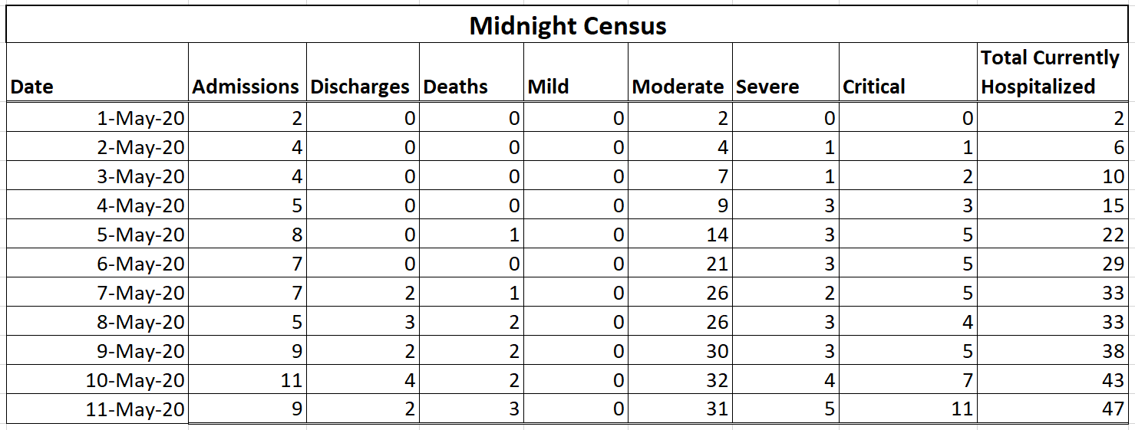
Note: this example assumes you will have access to all pertinent data. but it is likely that not all data will be available. In these cases, it will be necessary to apply a ratio to obtain an estimate for how many patients per severity are in a bed for COVID-19 treatment at a certain point in the day. In this example, you will see there are no mild cases listed because only moderate, severe and critical patients are hospitalized in this country. As you are filling out this form, it is important to document any assumptions or estimations that are made.

Step 2. Review your data
You may begin Step 2 even as you are compiling the data sheets described in Step 1. For this stage of the process, you will need to critically review the data you are gathering to be sure it is reasonable. You will also need to locate any gaps in your data and determine where you need to use ratios or estimates from other data, or how you can use the data you have to approximate the missing pieces.

Continue your data collection sheets
As you are compiling the data collection sheets, it is important to update them regularly. In particular, the COVID-19 Daily Reported Data and the Midnight Census require data to be input daily. It is important to continue compiling the data even as you continue through the next steps of the process.
As you are compiling your data collection sheets, you may find it helpful to make note of the comorbidities of people presenting to the hospital to help predict the level of severity that they might experience during their hospitalization with COVID-19. The facility management teams may find these data useful in predicting which patients may end up critically or severely ill. This suggestion is optional and not necessary to populate the Adaptt and HWFE tools, but it may prove useful to facility managers.

Document and check your assumptions
You will likely find that you do not have access to all the data requested for the data collection sheets. Even if you don’t have perfect data, you can still use the sheets and populate the Adaptt and HWFE tools by using estimates and ratios. When you do use estimates and ratios, it important to document all assumptions so that they can be referenced and checked regularly.

Step 3. Populate the tools
Once you have gathered the data collection sheets and documented the assumptions made to address data gaps, you may begin to populate the Adaptt and HWFE tools. It is important to populate the tools in the correct order listed below.
Box 1. Adaptt Surge Planning Tool – helpful links
- The main page for the Adaptt Surge Planning Tool describes the purpose of the tool created by the WHO Regional Office for Europe.
- Detailed instructions and a tutorial are available to guide the learning process.
- Please note that the tool used in this toolkit is V02.15. There may be a new version by the time you implement your tool; however, the content is essentially the same and can easily be adapted.

Adaptt Surge Planning Support Tool
You will need to reference the instructions and tutorial (Box 1) to familiarize yourself with the tools. Once you have a working knowledge of the tools, you may then begin to load the data.
Follow the Adaptt instructions and tutorial for inputting data into the tool. Once you have followed the tutorial, you may have further questions about where to input data from the data collection sheets. Fig. 9–16 may provide helpful visuals in determining where data should be inputted.
Fig. 9. Adaptt Tool tabs
The Facility Data Collection Sheet, Professional Activities Data Collection Sheet, and Available Working Time are used in this tab.
COVID-19 Daily Reported Data Sheet will be input here.

Note: this screenshot demonstrates where data from the data collection sheets will be inputted to populate the Adaptt Tool.

Fig. 10. Adaptt Tool: Surge_Predicted_Impact tab, epidemiological model section
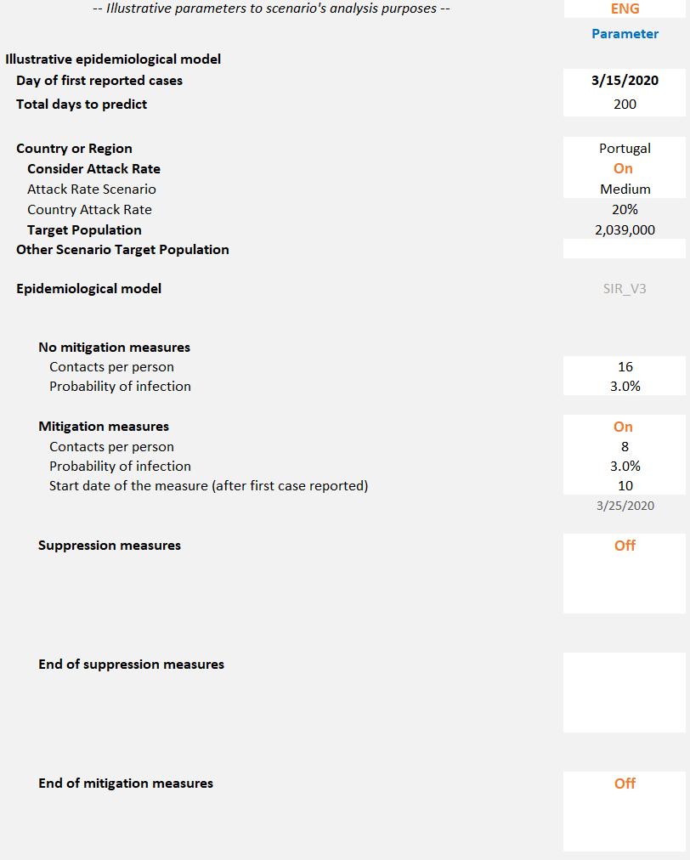
As suppression or mitigation policies are ended, you may update the model here.
Based on government policies and contact tracing data.
Use “Target Population” for entire country; use “Other Scenario Target Population” when targeting a region, using regional population.
If further government policies are enacted, you may choose to use this feature.
Based on government policies such as closing schools, requiring public use of masks, etc.
Note: this screenshot from the Adaptt Tool, Surge_Predicted_Impact tab, epidemiological model section demonstrates how to customize the surge curve to your local context. When modelling for an entire country, you may leave “Consider Attack Rate” On so it will apply the attack rate to the country population. When modelling for a region, however, you may turn “Consider Attack Rate” Off, multiply the desired attack rate by the region’s population and manually input the result into “Other Scenario Target Population.” Contacts per person can be obtained based on contact tracing data and government policies, and as mitigation or suppression measures can be accounted for as they are enacted or ended. As you are filling out the tool, it is important to document any assumptions or estimations that are made.

Fig. 11. Adaptt Tool: Surge_Predicted_Impact tab, Hospital activity and practices (in/out) section
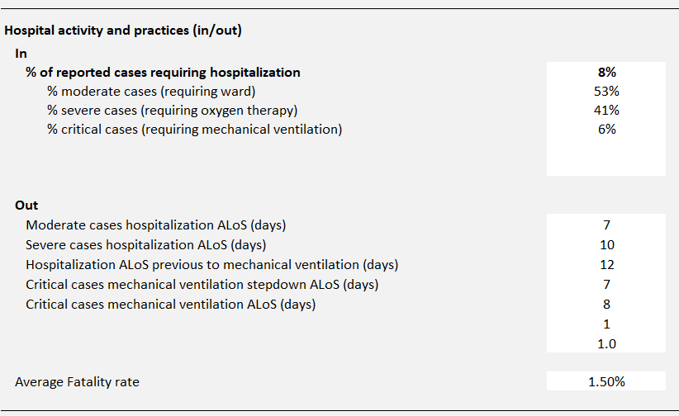
These numbers are obtained from the ministry of health and local experts. They may need to be updated as policies change and more data are available.
These cells must have the value of 1 and not be deleted; otherwise the surge curve will disappear from your results.
You may choose to keep the default fatality rate or update based on your context.
Note: this screenshot from the Adaptt Tool Surge_Predicted_Impact tab, Hospital activity and practices (in/out) section demonstrates how to customize the surge curve to your local context. Please note that for the % of reported cases requiring hospitalization, the data for moderate, severe and critical cases apply only to the number of people hospitalized, not all patients with confirmed COVID-19. These data should be specific to the geographic region you’re monitoring. Data about average length of stay are obtained from the ministry of health and local experts. You may also choose to update the average fatality rate to fit the local context. Please note that if your country hospitalizes all COVID-19 cases, you will need to change the % of reported cases requiring hospitalization row to 100% and combine the % moderate and % mild cases together in the % moderate cases (requiring ward) row. As you are filling out the tool, it is important to document any assumptions made.

Fig. 12. Adaptt Tool: Surge_Predicted_Impact tab, Installed capacity (to COVID patients) section
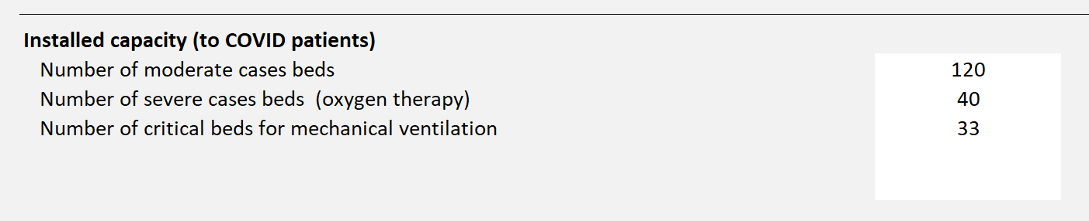
Obtained from the Facility Data Collection Sheet
Note: this screenshot from the Adaptt Tool, Surge_Predicted_Impact tab, Installed capacity (to COVID patients) section demonstrates how to customize the surge curve to your local context. These data are obtained from the Facility Data Collection Sheet and should be specific to the geographic region you’re monitoring. Please note that the number of mild case beds are not included because it is assumed that these cases will not be hospitalized. If your country hospitalizes all cases, including mild cases, you will need to add the number of mild and moderate together and incorporate into the Number of moderate cases beds row. As you are filling out the tool, it is important to document any assumptions made.

Fig. 13. Adaptt Tool: Surge_Predicted_Impact tab, Human resources section
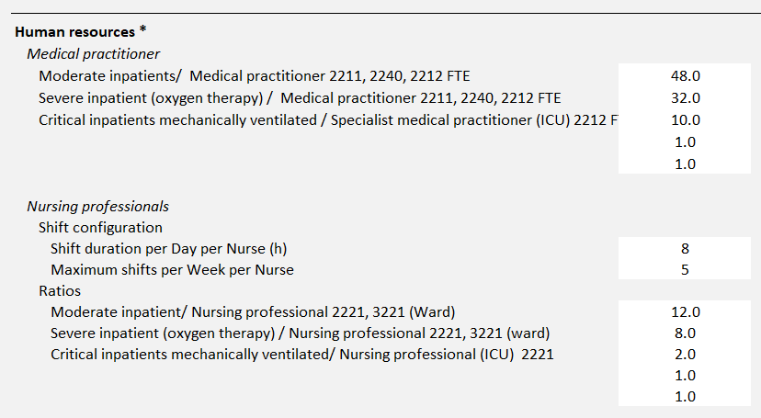
These cells must have the value of 1 and not be deleted; otherwise the surge curve will disappear from your results.
Obtained from calculations using the Professional Activities and the Available Working Time Data Sheets.
Note: this screenshot from the Adaptt tool, Surge_Predicted_Impact tab, Human resources section demonstrates how to customize the surge curve to your local context. The Professional Activities Data Collection Sheet and Available Working Time Data Collection Sheet are used together to calculate the data needed for the Human Resources row. The data required are commonly used on defining ward staff and in a simplistic way correspond to the number of health-care professionals per bed. The tool assumes the full-time equivalent medical doctors per bed independently on the shift’s configuration. For nurses and health-care assistants, the tool assumes that all shifts are equally composed. So, you should consider the shifts configuration (shift duration per day and maximum shifts per week) and the exact number of health-care professionals per shift. Another way to calculate it is, for example, to look at the Sample Professional Activities Data Collection Sheet and the Sample Available Working Time Templates shown in Fig. 2 and 3. The Sample Professional Activities Sheet shows that a nursing professional (critical care) spends 10.5 hours per patient in a 24-hour period. The Adaptt Tool asks for a ratio of how many patients each nurse can care for during one shift. If we divide 10.5 hours per patient by three shifts, we find that this nurse provides 3.5 hours of care per patient in critical care. To determine how many patients that would be per shift, we need to divide the nurse’s number of working hours in a year by 3.5 hours per patient. Using the Sample Available Working Time Sheet, we see that the nurse has 216 available working days, which equals 1728 available working hours. If we divide 1728 hours by the 3.5 hours per patient, then the nurse cares for 494 patients in one year: 494 patients per year/216 available working days = 2.3 patients per shift, which we can round down to 2 in this case.
Fig. 14. Adaptt Tool: Surge_Predicted_Impact tab, HR capacity (to COVID patients) section
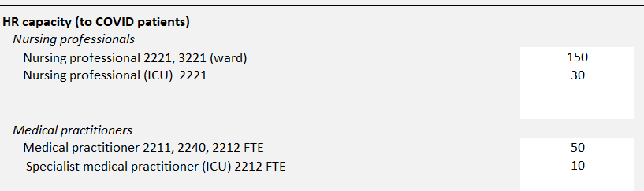
Obtained from Staffing Data Collection Sheet.
Note: this screenshot from the Adaptt Tool, Surge_Predicted_Impact tab, HR capacity (to COVID patients) section demonstrates how to customize the surge curve to your local context. Using numbers of staff per cadre who care for patients with COVID-19, you will be able to see staff capacity as the surge is predicted. Please note that this is only for staff who care for patients with COVID-19 in the region of interest, and that it does not predict per facility.

Fig. 15. Adaptt Tool: Surge_Predicted_Impact tab, HR occupational risk section
Note: this screenshot from the Adaptt Tool Surge_Predicted_Impact tab, HR occupational risk section demonstrates how to customize the surge curve to your local context. You can customize the daily probability risk and the number of days that is defined locally for sick leave and quarantine due to COVID-19. The length of quarantine for health-care workers can depend on the spread of the outbreak and is weighed against the need to maintain services. The daily probability should be used to develop different scenarios according to the local circumstances.
Fig. 16. Adaptt Tool: Surge_Predicted_Impact Tab, Human resources to contact trace & home care follow-up section

Duration of contact follow-up (days) and capacity to contact trace (first contact and follow-ups)

Average number of contacts per case

Note: this screenshot from the Adaptt Tool Surge_Predicted_Impact tab, Human resources to contact trace & home care follow-up demonstrates how to customize the surge curve to your local context. You can customize the number of contacts per case. Usually, it varies from 2–3 close contacts during lockdown and 7–20 close contacts pre-lockdown. Monitoring activities vary by country and depend on the spread of the outbreak, ranging from daily active follow-up by phone call or text message, to less frequent active follow- up (every other day or once a week) or no active follow-up (the contact calls the public health team if they develop symptoms). The average time was estimated to be between 45 minutes and one hour (up to two hours for complex cases). During the interview, the list of contacts and their classification into high- and low-risk exposure is developed. The average time per contact is estimated to be between 3.5 and 20 minutes per phone call. This call is to inform the contacts of their exposure and give them information about self- quarantining, hand hygiene, monitoring for symptoms and what to do if they develop symptoms. High-risk contacts are asked to self-quarantine for 14 days following their last exposure. The home-care follow-up considers the number of patients followed exclusively at home and the percentage of cases discharged from the hospital that require home-care follow-up.

View your results
After following the Adaptt instructions and tutorial and studying the additional information provided in the toolkit on how to translate the data collection sheets, you should now have data to show the predicted impact of the surge for your region based on the data you have entered.
Fig.s 17–21 show the results of the data entered into the Adaptt Tool. It is very important not to stop after viewing the results; a vital step that needs to occur at the same time is validating your assumptions, as shown in the Validate the Data and Check Your Assumptions section of the toolkit (see Box 2).
Fig. 17. Adaptt Tool: Surge_Predicted_Impact tab, Bed capacity graph
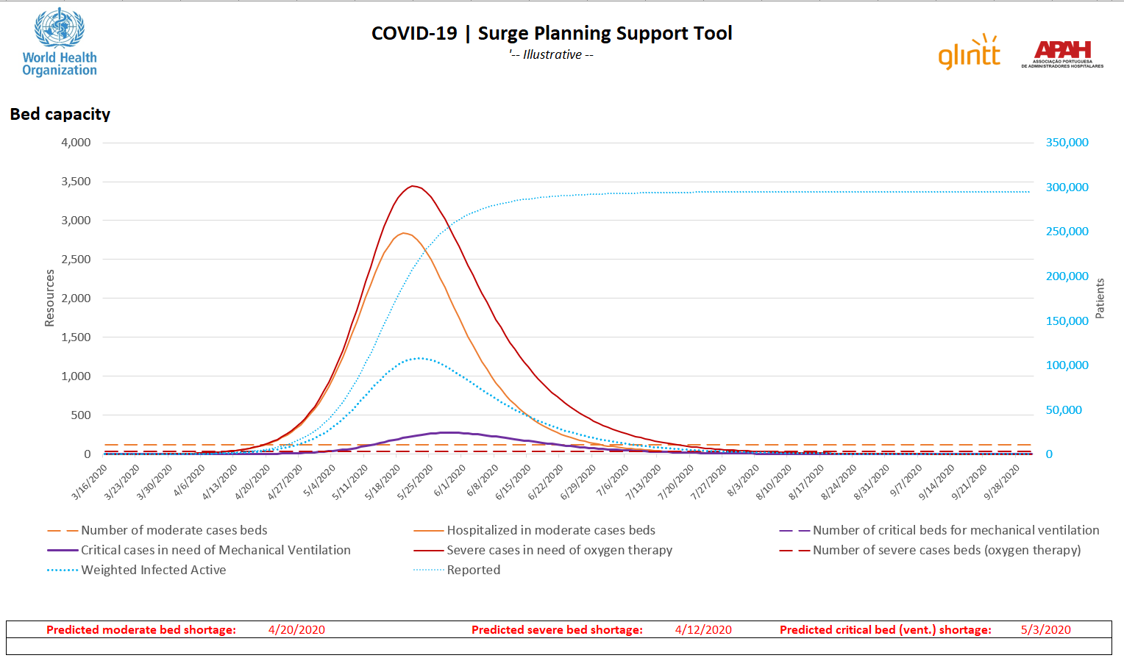
Note: this screenshot from the Adaptt Tool, Surge_Predicted_Impact tab, Bed capacity graph provides a visual of the results related to bed capacity after all data have been inputted. Please note that the y-axis on the left is specific to resources, while the y-axis on the right is specific to the number of active patients. In this example, the predicted moderate bed shortage is 24 April 2020, predicted severe bed shortage is 12 April 2020, and predicted critical care (ventilated) bed shortage is 3 May 2020. The surge is predicted to hit its peak around 25 May 2020. It is important to verify the model by checking your assumptions and comparing the modelled data with the actual data, as shown in Box 2.
Fig. 18. Adaptt Tool: Surge_Predicted_Impact tab, Human resources needed graph
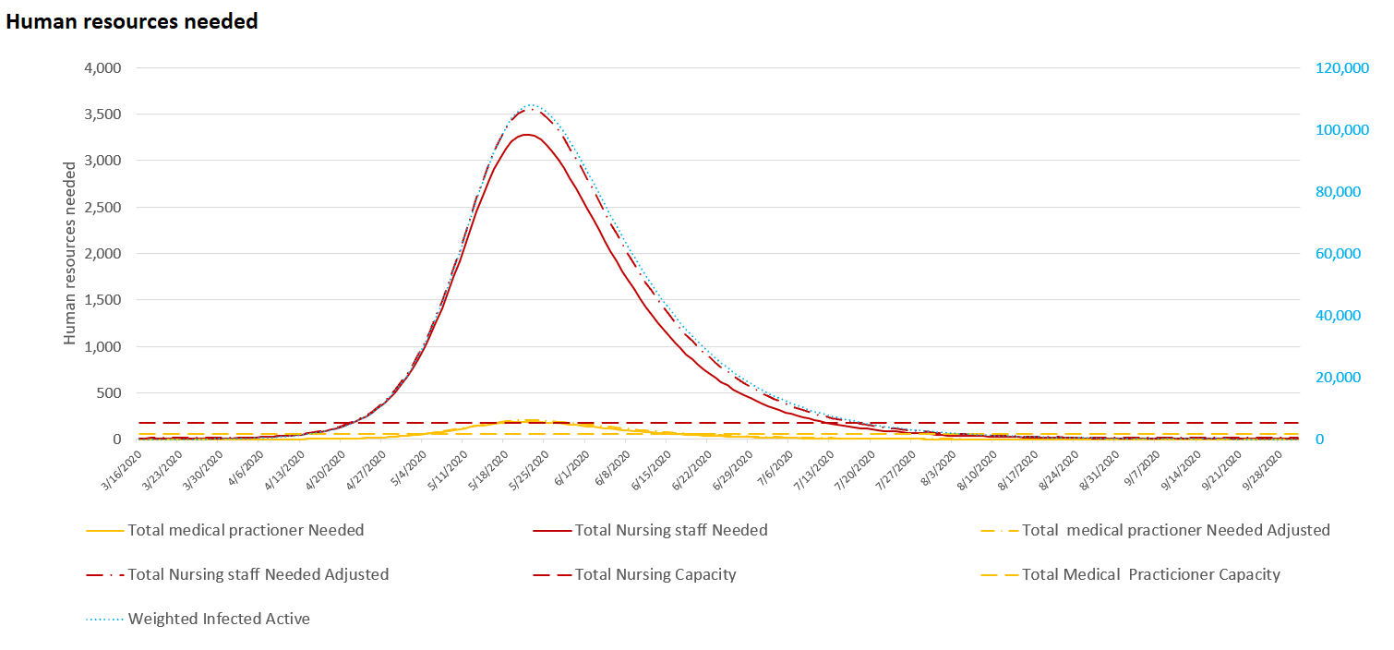
Note: This screenshot from the Adaptt Tool, Surge_Predicted_Impact tab, Human resources needed graph provides a visual of the results related to human resources after all data have been inputted. Please note that the y-axis on the left is specific to human resources, while the y-axis on the right is specific to the number of active patients. In this example, the total number of medical practitioners needed will exceed capacity around 4 May 2020 and the total number of nursing staff needed will exceed capacity around 20 April 2020. Please note that the graphics for health professionals “Needed Adjusted” takes into account the daily probability of infection by health professionals and days missed due to COVID-19 infection or quarantine, and therefore represents a higher number of health professionals needed.

Fig. 19. Adaptt Tool: Human resources needed by skill graph
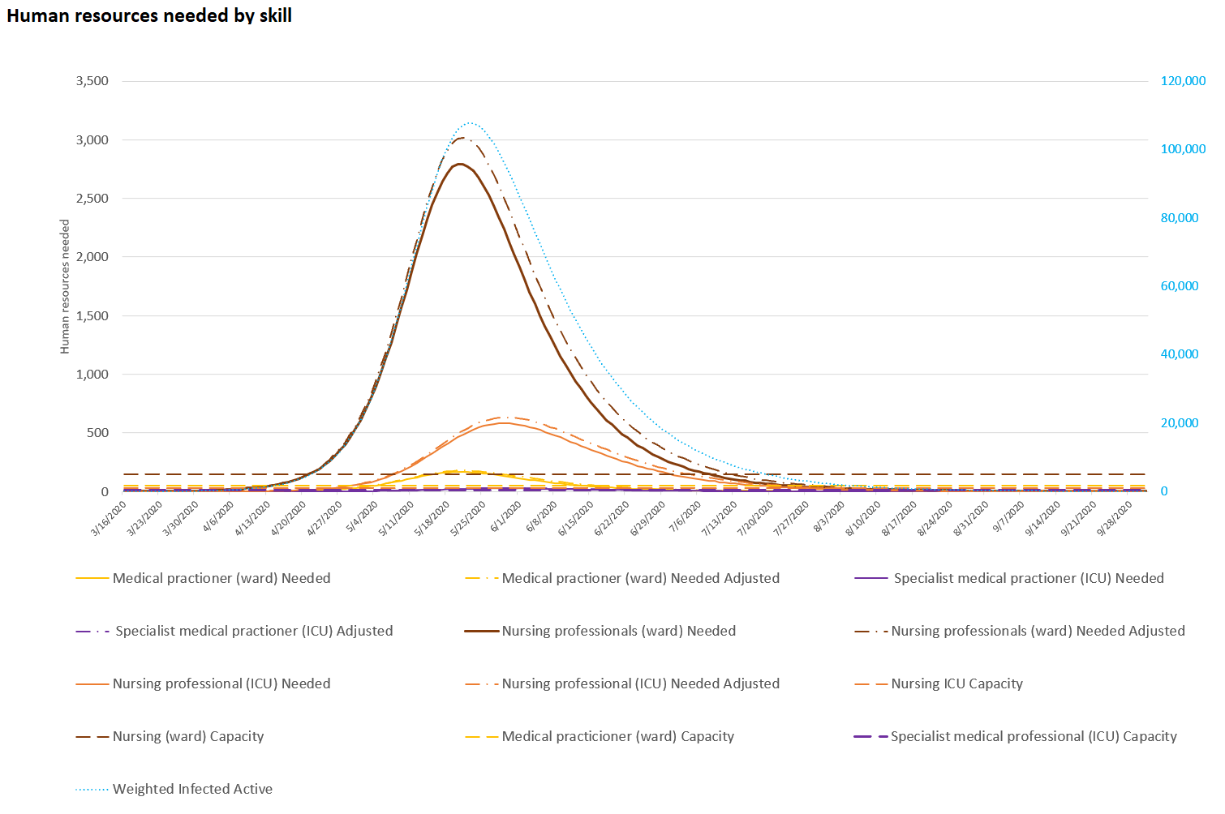
Note: this screenshot from the Adaptt Tool, Surge_Predicted_Impact tab, Human resources needed by skill graph provides a visual of the results related to human resources needed by skill after all data have been inputted. Please note that the y-axis on the left is specific to human resources, while the y-axis on the right is specific to number of active patients. In this example, the number of medical practitioners (ward) needed will exceed capacity around 27 April 2020, the number of specialist medical practitioners (ICU) needed will exceed capacity almost immediately, the number of nursing professionals (ward) needed will exceed capacity around 20 April 2020, and the number of nursing professionals (ICU) needed will exceed capacity around 20 April 2020. Please note that the graphics for health professionals “Needed Adjusted” takes into account the daily probability of infection by health professionals and days missed due to COVID-19 infection or quarantine, and therefore represents a higher number of health professionals needed.

Fig. 20. Adaptt Tool: Contact tracing graph

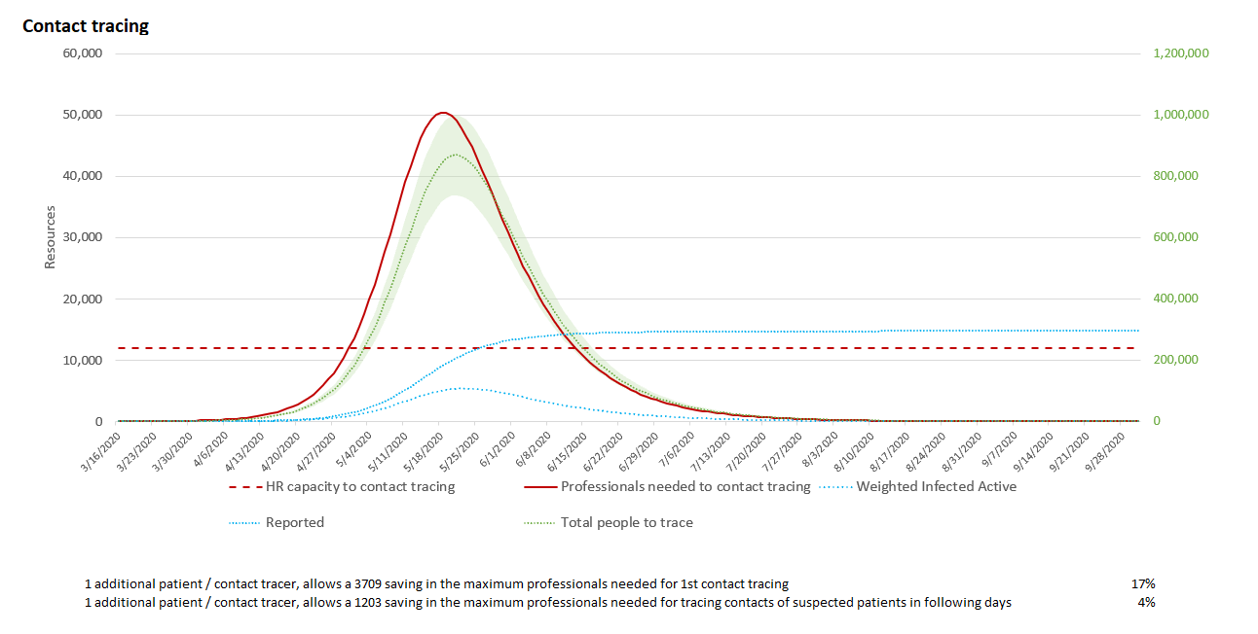
Note: this screenshot from the Adaptt Tool, Surge_Predicted_Impact tab, Contact tracing graph provides a visual of the results related to human resources needed to contact trace. Please note that the y-axis on the left is specific to the human resources needed, while the y-axis on the right is specific to the number of people to trace, active patients and total patients. Below the graph, you can have an overview of increasing the capacity of contact to trace per contact tracer.
Fig. 21. Adaptt Tool: Home-care follow-up graph
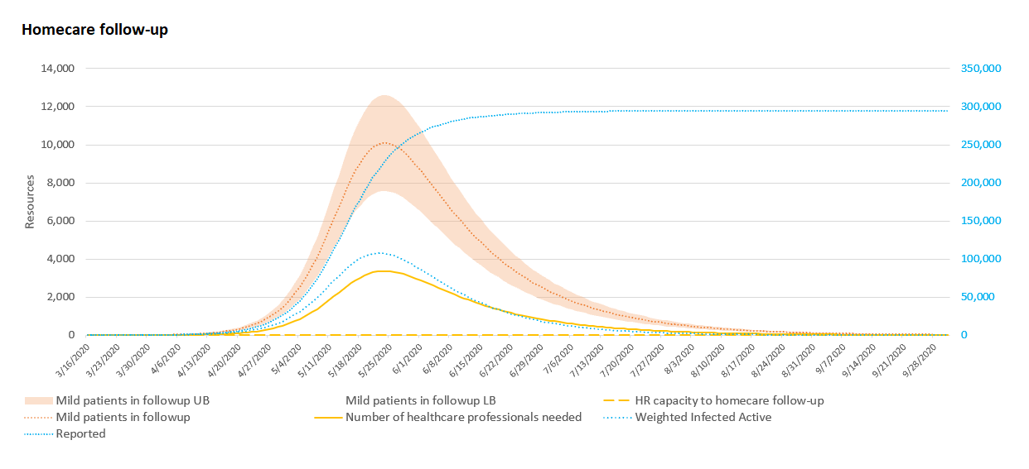
Note: this screenshot from the Adaptt Tool, Surge_Predicted_Impact tab, Home-care follow-up graph provides a visual of the results related to human resources needed to provide home care. Please note that the y-axis on the left is specific to the number of patients that require home-care follow-up and the human resources needed, while the y-axis on the right is specific to the number of active patients and total patients.

Validate the data and check your assumptions
Now you have viewed your results, it is time to validate the data to be sure they are appropriate and make sense for your context. You may need to adjust some of the parameters to fit the local context, such as applying suppression or mitigation measures depending on local health policies, adjusting the number of contacts, or adjusting the attack rate depending on the context. Box 2 demonstrates how you can validate the data from the Adaptt Tool by comparing the modelled predictions with actual data from your region.
It is important to check your assumptions regularly, especially as you obtain new data, or if you need to change your assumptions based on reality on the ground. For example, perhaps your region hospitalized all positive COVID-19 cases at the beginning of the epidemic, but once a facility ran out of beds, it hospitalized only those who needed inpatient medical care. This new policy will impact the number of hospitalized cases in the Adaptt Tool, and if it is not updated, you will have inaccurate estimates. In particular, it will be important to regularly update the average length of stay per severity and the rates of hospitalization.

Paste from Simulation Results
Paste from data sheet
Box 2. How can I be sure that the Adaptt Tool’s predictions are realistic?
- One way to validate the Adaptt Tool is to compare the model’s predictions with your actual case data gathered from confirmed cumulate cases recorded in the COVID-19 Daily Reported Data Collection Sheet.
- To compare the predictions with actual case data, you may add columns in the COVID19_DailyReportedData and copy the simulated data so you can see if the modelled data are appropriate.
- If the modelled and confirmed cases vary significantly, you may need to check your assumptions on the numbers of contacts/person, the attack rate, in the population, the probability of infection, or other assumptions.

HWFE
Box 3. Health workforce estimator – helpful links
- The main page for the HWFE describes the purpose of the tool created by the WHO Regional Office for Europe.
- A detailed user guide is available to guide the learning process.
- Please note that the tool used in this toolkit is V3.0. There may be a new version by the time you implement your tool; however, the content is essentially the same and can easily be adapted.
You will need to reference the user guide (Box 3) to familiarize yourself with the HWFE. Once you have a working knowledge of the tool, you may then begin to load the data. After viewing the user guide, you may still have questions about where to upload information from the data collection sheets. Fig. 22–25 may be helpful in guiding this process. The HWFE needs to be populated by starting with the Staff Category tab first, then Health Facility tab, then Health Care Resources tab, then the Role Substitution tab. Note that all cells highlighted in yellow are unlocked for data input, grey highlighted areas are locked and cannot be changed, and green text or numbers are linked to other worksheets and should not be changed. One exception is explained below for adjusting professional activities based on your context.
Fig. 22. HWFE Tool tabs

Adaptt data imported here.
Role Substitution Data Collection Sheet uploaded here.
Staffing Data Collection Sheet uploaded here.
Facility Data Collection Sheet uploaded here.
Professional Activities uploaded here.

Note: this screenshot demonstrates where data from the data collection sheets will be inputted to populate the HWFE tool.
Note that the HWFE can be used with the inbuilt professional activity standards linked to the group ID in Fig. 23. However, if some activities are not appropriate for your context (ECMO may not be available, for instance), you may replace the grey cells with green text in the Staff Category sheet to reflect your own activity standards.
Fig. 23. HWFE Tool: Staff Category tab
You may hide unused staff category.

rows for easy visualization of data.
Do not change, meant to reflect 40-hour workweek

Manually input from Professional Activities.

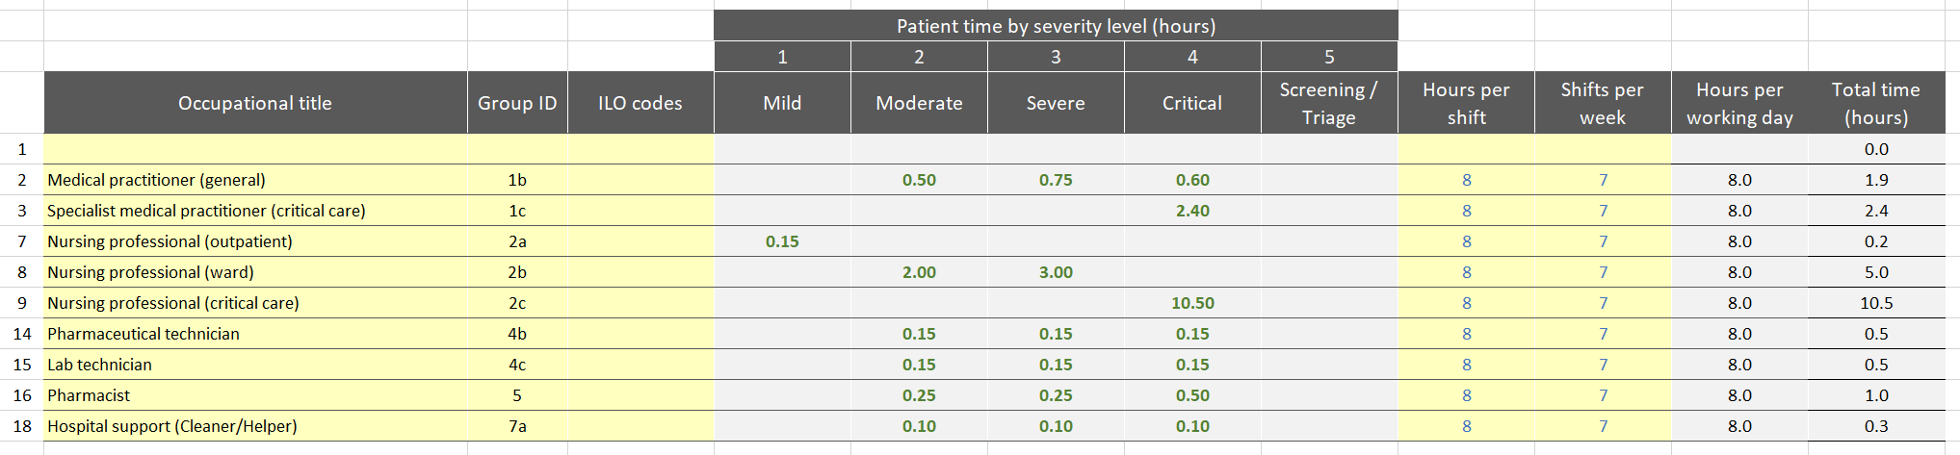
Note: this screenshot demonstrates the HWFE Staff Category tab, where you will manually input data collected from the Professional Activities Data Collection Sheet. You should update the Occupational title based on the health worker cadres used in your Professional Activities but do not change the Group ID column. These titles will be populated across the rest of the spreadsheet, so do not need to be re-entered. You may then hide unused staff category rows if desired.

Fig. 24. HWFE tool: Health Facility tab
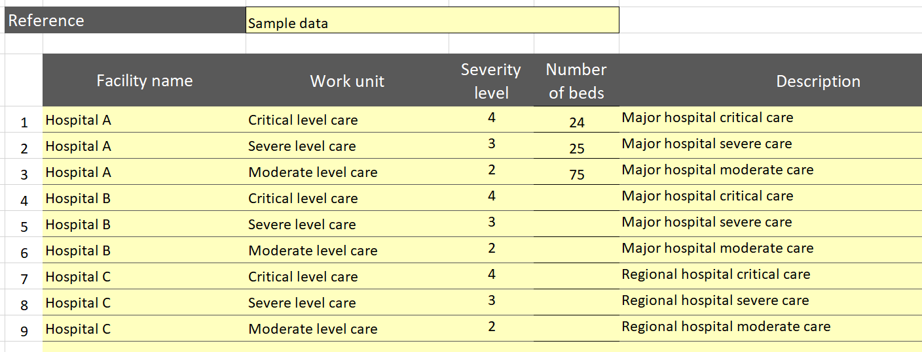
Note: this screenshot from the Health Facility tab of the HWFE Tool requires manual input of facility name, work unit, severity level, number of beds available for COVID-19 and description. It will then link facility names in the Health Care Resources tab. In this example, we have inputted the number of beds available for COVID-19 at Hospital A by severity.
Fig. 25.
Manually input from Staffing Data Collection Sheet.
HWFE Tool: Health Care Resources tab
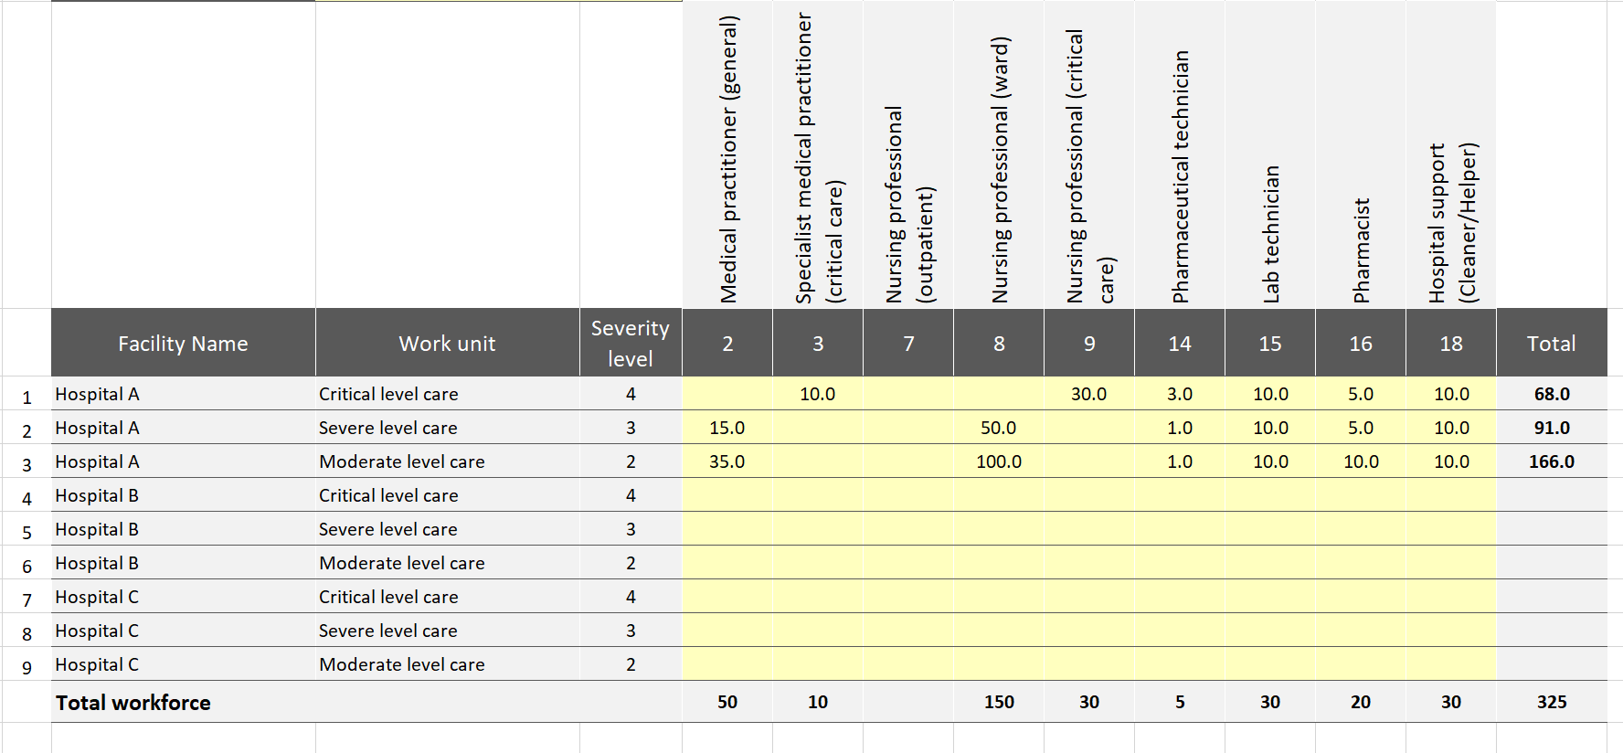
Note: this screenshot from the Health Care Resources tab of the HWFE Tool shows how data from the Staffing Data Collection Sheet should be manually inputted. Please note that this is the number of staff designated for patients with COVID-19.
If your team elected to fill out the optional Role Substitution Data Collection Sheet, you may upload the data into the Role Substitution tab, which allows you to see the impact of identifying potential workforce groups to augment the current workforce (Fig. 26). This tab could be of particular help to hospital administrators who need to decide how to substitute the existing workforce with other potential sources.
Fig. 26. HWFE Tool: Role Substitution tab
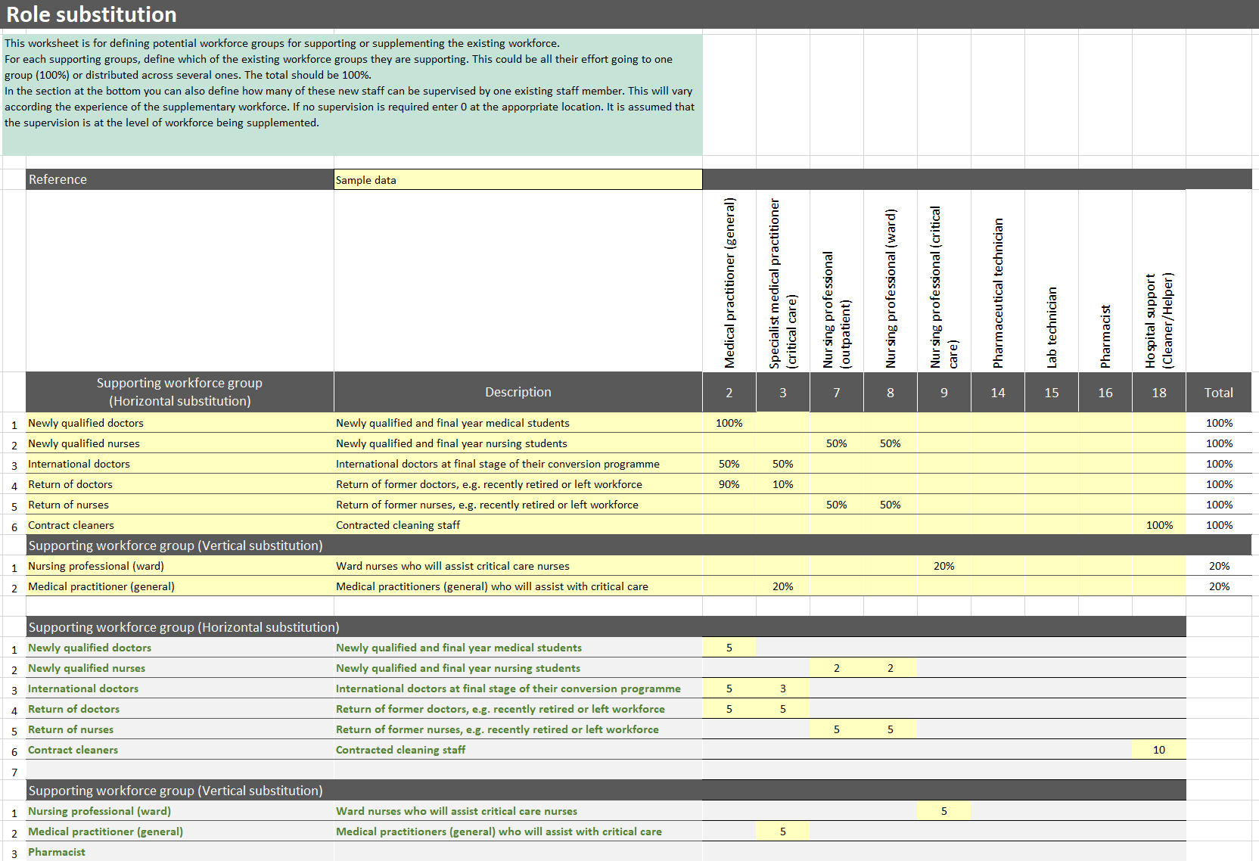
Note: the Role Substitution tab allows the user to see the impact of supplementing the existing Healthcare workforce with other qualified roles, such as newly qualified professionals, recently retired individuals and contract workers. In this example, it was decided where each supporting workforce group could horizontally substitute. As can be seen, 100% of newly qualified doctors will be used as medical practitioners (general). Of the newly qualified nurses, 50% will be allocated as nursing professionals (outpatient) and 50% as nursing professional (ward). It was also determined how many supporting workers a current health worker could supervise. For example, a medical practitioner (general) is able to supervise five newly qualified doctors in this case. It was also determined how health worker cadres could be vertically substituted. In this example, a nursing professional (ward) can spend 20% of their time supporting nursing professionals (critical care), and a nursing professional (critical care) would supervise five nursing professionals (ward).
With the data properly inputted, you can now look at the Analysis tabs to see the results, validate the data and check your assumptions.

View your results
After following the HWFE user guide and studying the additional information provided in the toolkit on how to translate the data collection sheets, you should now have data to show the health worker needs for your region based on the data you have entered.
Fig. 27–31 show the results of the data entered into the HWFE Tool. It is very important not to stop after viewing the results; a vital step that needs to occur at the same time is validating your assumptions, as shown in the Validate the Data and Check Your Assumptions section of the toolkit.
Fig. 27. HWFE: Required Staff tab
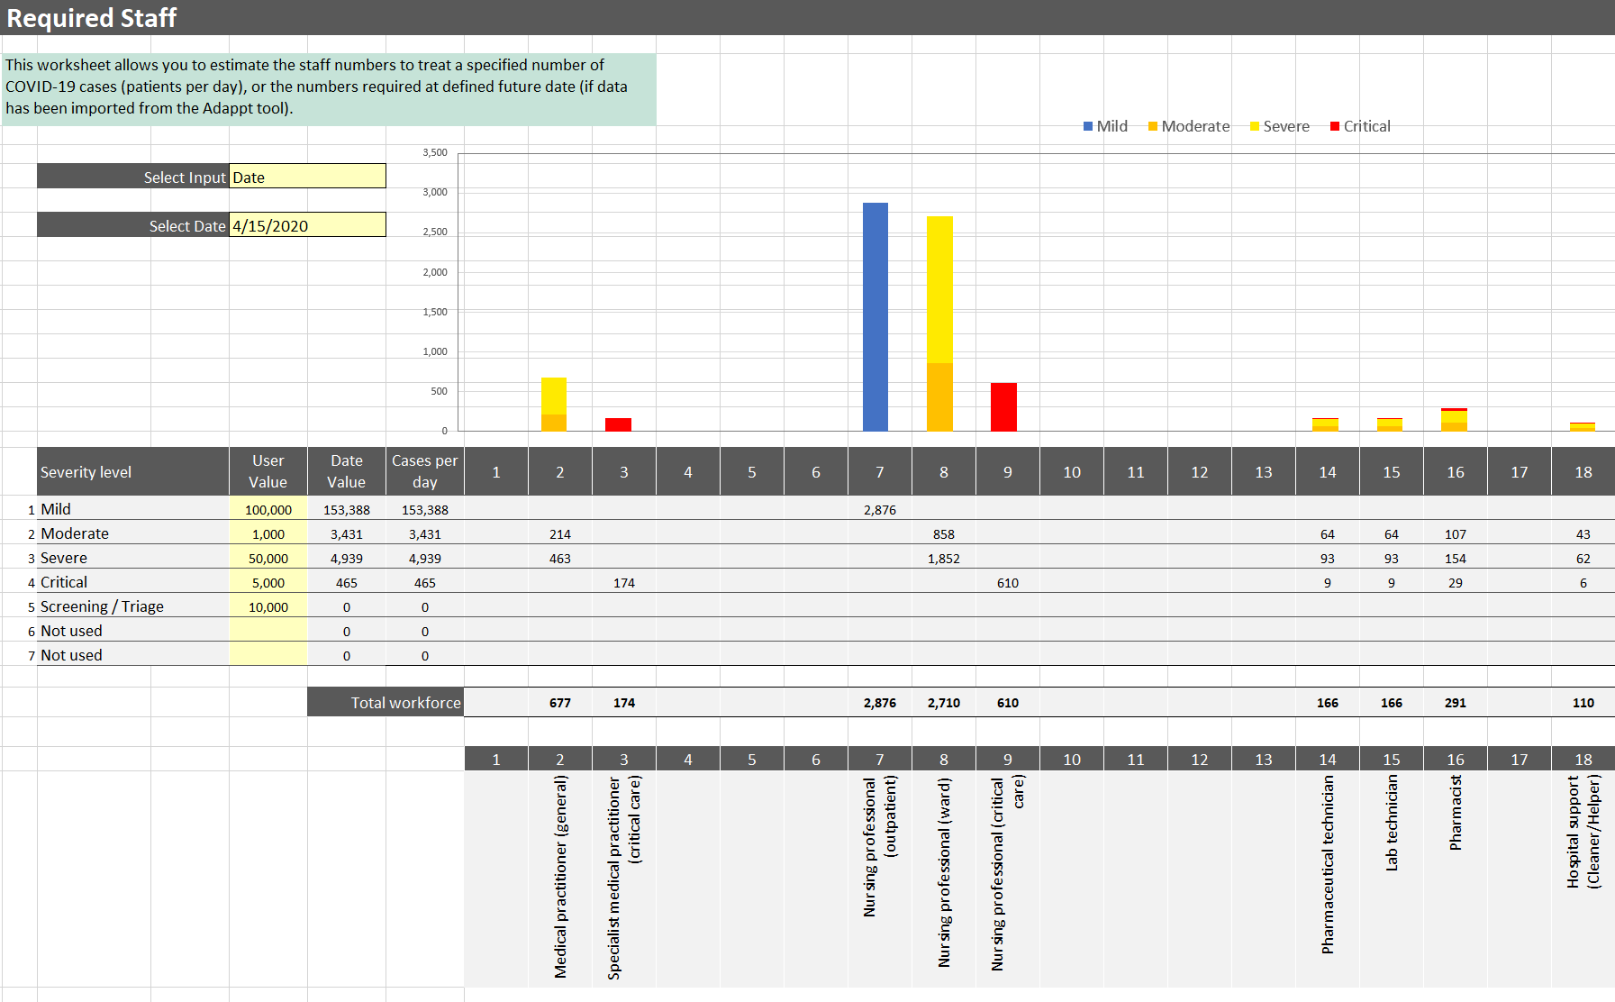
If not using the Screening/Triage or Not used columns, you may go to COVID-19 Cases tab and clear contents from these columns
Note: the Required Staff tab of the HWFE allows for visualization of health worker needs. You may manually input projected data in the User Value column, or you may select a date if you have imported data from the Adaptt Tool. In this example, we selected a date to use data from Adaptt from 15 April 2020, which predicted that there would be a need for 677 medical practitioners (general), 174 specialist medical practitioners (critical care), 2876 nursing professionals (outpatient), etc.

Fig. 28. HWFE: Policy Options tab
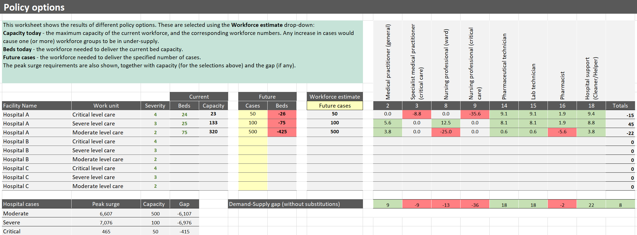
Note: the Policy options tab of the HWFE allows you to see Healthcare workforce gaps based on current capacity, current number of beds, or future number of cases, depending on the drop-down selected from the Workforce estimate column. Current capacity refers to the maximum number of cases that the current workforce can accommodate. In this example, Hospital A has 25 severe-level beds, but the capacity to care for 133 severe-level patients. Current number of beds compares the current beds to the capacity and shows the gap in the workforce. Future cases can be inputted manually; in this example, we are planning for 50 critical patients, 100 severe patients and 500 moderate patients. With these future case numbers, we can see that Hospital A will be short of nine specialist medical practitioners (critical care), 13 nursing professionals (ward), 36 nursing professionals (critical care) and two pharmacists. It will also have an oversupply of medical practitioners (general), pharmaceutical technicians, lab technicians and hospital support. These data can help Hospital A to plan for a shortage and determine how to use their oversupply of some cadres to support the undersupply of others.

Fig. 29. HWFE: Skill Mix tab
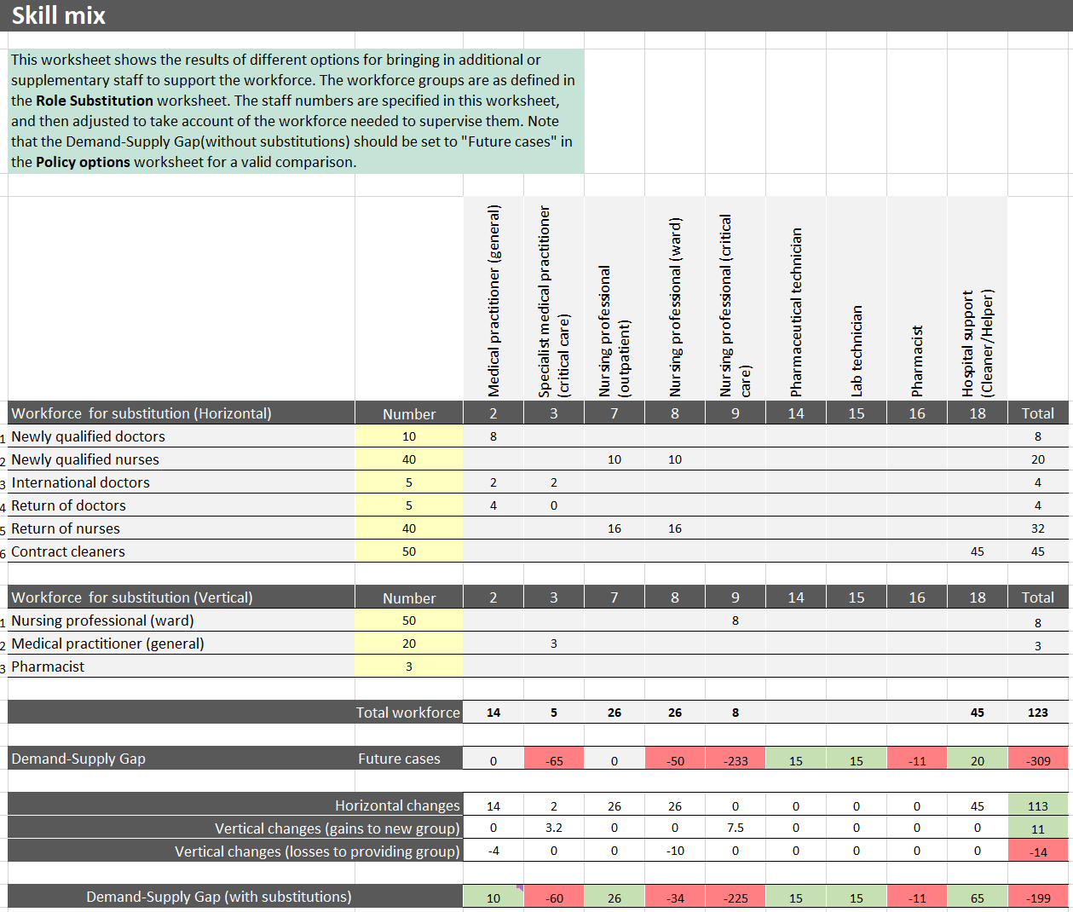
Note: the Skill mix tab of the HWFE shows an analysis of how alternate workforce groups may be used to augment the existing Healthcare workforce. The number of workforce available for substitution is manually inputted into the yellow boxes. The table then pulls data from the Role Substitution tab to calculate the impact of adding substitute health workers into the system. For example, we can see that if we are able to use 10 newly qualified doctors, the cumulative impact will be an additional eight available new medical practitioners (general) (the cumulative impact is less than the number of substitute staff because it takes into account existing health workers who will be needed to supervise the substitute staff. In this example, one medical practitioner (general) can supervise five newly qualified doctors. So, two current medical practitioners (general) will not be practising at their full capacity because they will be supervising the 10 newly qualified doctors: 10 – 2 = 8). Additionally, we can see that when using vertical substitution of nursing professionals (ward) to assist the nursing professionals (critical care), the 50 nursing professionals (ward) will spend 20% of their time in critical care, as was determined by the Role Substitution tab, and one nursing professional (critical care) will supervise five nursing professionals (ward), as was also determined by the Role Substitution tab. Vertically substituting these 50 nursing professionals (ward) will create a cumulative effect of eight new nursing professionals (critical care) (50 ward nurses x 20% = 10. Two critical care nurses will not be practising at full capacity because they will be supervising the 10 ward nurses: 10 – 2 = 8).

Fig. 30. HWFE: Surge tab
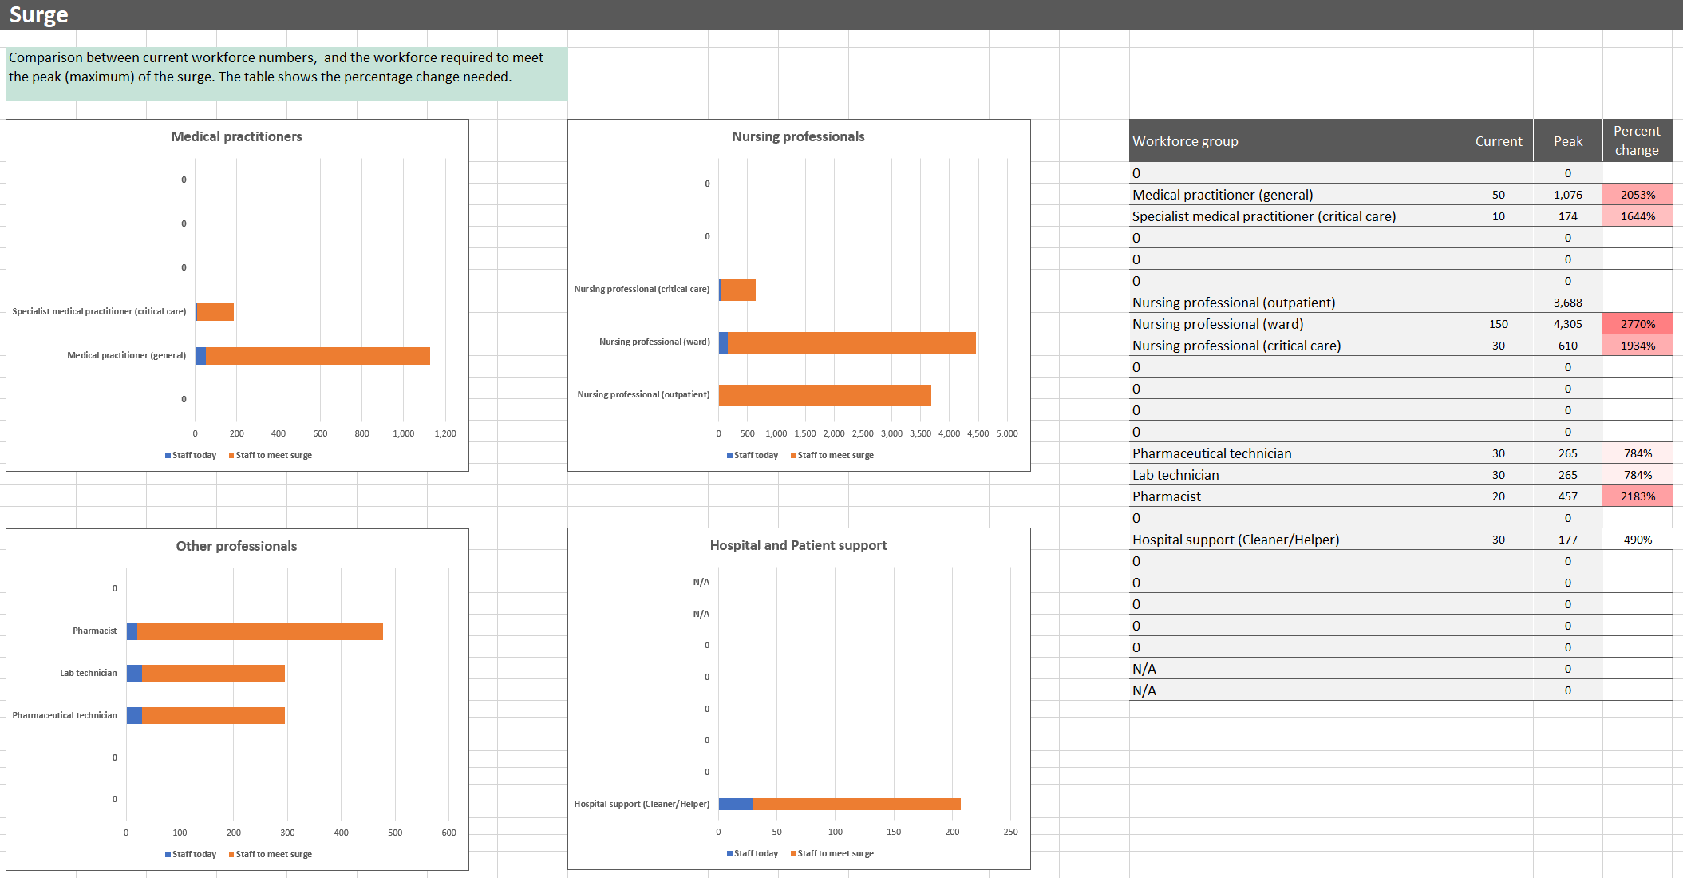
Note: the Surge tab of the HWFE compares the current workforce numbers with the numbers needed to meet the surge. The surge is calculated based on data from the Required Staff tab. In this example, we can see that although we have 50 medical practitioners (general) in the region, we will need 1076 to meet the needs of all patients during the surge. The table on the right allows you to see which health-worker categories will be most vulnerable during the surge. In this example, the greatest shortage will be for nursing professionals (ward).

Fig. 31. HWFE: Comparisons tab
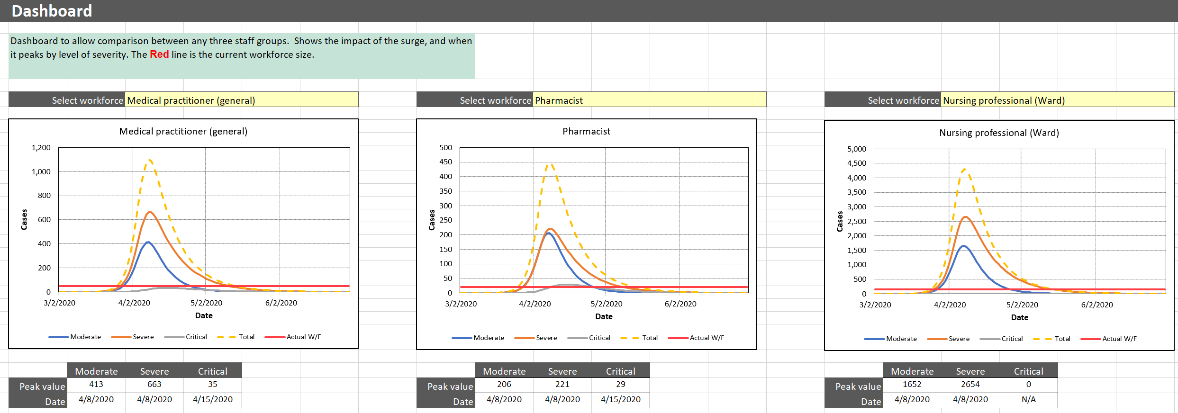
Note: the Comparisons tab in the HWFE provides a dashboard so that the impact of the surge can be compared among any three staff groups. In this example, the medical practitioner (general), pharmacist and nursing professional (ward) roles were selected. We can see that the peak for moderate and severe cases for pharmacists is 8 April 2020, when 206 pharmacists will be needed for care for moderate patients and 221 pharmacists will be needed to care for severe patients. The peak for critical cases is 15 April 2020, when 29 pharmacists will be needed.

Validate the data and check your assumptions
As you upload the data, you will need to validate them to make sure they are reasonable and make sense for your country context. You will also need to reflect on assumptions made throughout the data collection process regularly and update the data as needed. The best way to validate your data is to compare projected figures with actual data collected on the ground.
The most important part of validating your results from the HWFE is reviewing the professional activities to be sure they reflect the local context appropriately. If the health-worker predictions match local data, you may need to consult with health workers again to better understand how many hours they spend with a patient in a 24-hour period.

Contact tracing
Box 4. Contact Tracing tool – helpful links
- The main page for the CTT describes the purpose of the tool created by the WHO Regional Office for Europe.
- A detailed user guide is available to guide the learning process.
- Please note that the tool used in this toolkit is V2.0. There may be a new version by the time you implement your tool; however, the content is essentially the same and can easily be adapted.

You will need to reference the user guide (Box 4) to familiarize yourself with the CTT. Once you have a working knowledge of the tool, you may then begin to load the data. After viewing the user guide, you may still have questions about where to upload information from the data collection sheets. Fig. 32–35 may be helpful in guiding this process. Note that all cells highlighted in yellow are unlocked for data input, and grey highlighted areas are locked and cannot be changed.

Fig. 32. CTT tabs
Data sets for the Forward Planner
Calculations performed (not editable)
Default parameter settings used by the tool
Estimation of staff required over time
Estimation of Contact Tracing staff required per day.

Introduction
The COVID-19 Contact Tracing tool has been developed by the WHO Regional Office for Europe to estimate the staff required to track and trace COVID-19 cases. It may be used with default settings to estimate changing staff requirements over a four-month period, where forecast case numbers are available. Different categories of staff are not distinguished.
The spreadsheet models the following contact tracing process.

Identify
- Confirmed cases are identified to the contact tracers. A confirmed case is an individual infected with COVID-19, confirmed by a positive laboratory test result. Contact tracing may be performed for probable cases if comprehensive testing is not available (WHO, 2020).
- A case interview is conducted by contact tracing staff. This may be done by telephone, or travel may be required to interview the contact face to face. The percentage of interviews that require travel can be defined. Travel time can be adjusted for urban or rural settings, or a combination.
- Case contacts are identified. A contact is defined as anyone with exposure to a COVID-19 case from two days before to 14 days after the onset of illness (WHO, 2020). The number of contacts per case is influenced by the level of social distancing. Contacts per case can be set for different levels of social distancing.
- Details of the case interview are entered into a database, and the contacts are classified and prioritized as either high or low risk. The time to perform the case interview, collect and classify the information and enter into the database can all be defined.

Inform
- Contact interviews are held with each identified contact to collect information about the nature and duration of their contact with the infected individual and factors that may influence their vulnerability to COVID-19.
- Details of the contact interview are typically entered into a database. The interview time and database update time can be defined. As for case interviews, the percentage requiring travel for face-to-face meetings can be set.

Manage and monitor
- Contact tracers monitor these contacts for signs and symptoms over a follow-up period.
- The database is updated with any changes. Again, interview and database update times can be set, as well as travel parameters.

Test and isolate
- Contacts may be identified that have symptoms of COVID-19, either by the contact tracers or self-reported by the contacts themselves.
- Contacts are notified (if not aware already) and may be tested if symptomatic and asked to self-isolate or potentially referred to care. Travel and times for referral can be defined.

Use of digital tools
A variety of digital tools may be used to assist the contact tracing process. These include:
- outbreak response tools to provide contact tracers with support for online surveys, collecting and storing data sources, managing contact lists and flagging action;
- proximity tracing tools using GPS or Bluetooth technology to find and trace people who may have been exposed to an infected person; and
- symptom tracking tools for contacts to report their own symptoms that may indicate COVID-19 infection.
The digital tools, if in use, speed up the above stages to a greater or lesser degree. The percentage speed-up and the percentage of use of each tool will need to be adjusted to reflect local circumstances.

Using the tool
The CTT has six tabs as follows.
- How to use – a quick start guide.
- Contact Tracing – a simple estimator of the staff required per day to trace a specified number of confirmed contacts.
- Forward Planner – to estimate the staff required to trace new confirmed contacts arriving over an eight-week period.
- Parameter – to set the parameters used in the calculation. Default settings are provided but these should be confirmed.
- Calculations – a locked worksheet that shows the calculations used in the Contact Tracing and Forward Planner worksheets. This is provided to show how the results are calculated.
- Country Data – data on the number of new contacts per day over a specified time period, used in the Forward Planner.

Contact Tracing tab
The Contact Tracing tab is used to calculate the number of staff that would be required to monitor a steady-state number of COVID-19 cases, per day (Fig. 33). Steady state is where the number of cases arriving each day to contact trace has been the same for at least the length of the follow-up period. For example, if there are 100 confirmed cases per day and the follow-up period is 14 days, then the number of ongoing cases will increase to 1300 and then on day 14 the earliest 100 cases will close. In this situation, the number of cases arriving and the number of cases finishing at the end of the follow-up period will become stable. The number of staff required, using this estimate, represents the maximum that is likely to be needed to monitor the specified number of cases.
The parameters required are grouped into areas:
- situation – the confirmed COVID-19 cases to track per day and the level of social distancing
- contacts per case – expected from the level of social distancing in place
- policy options – actions we can take that effect the number of staff required for contact tracing
- use of digital tools – usage and uptake of digital tools, if available.

Fig. 33. CTT: Contact Tracing tab
The following steps should be taken (numbering follows Fig. 33 above).
- Define the average number of confirmed COVID-19 cases to track per day.
- Select the level of social distancing in the drop-down box. The number of contacts per confirmed case is pre-defined if Low, Medium or High is selected, or user-defined where its value can be input. Pre-defined values are set in the Parameters tab and may be edited.
- Social distancing may be Low/None – for example, advice but no enforcement. The pre-selected value in the above example is 15 contacts per case.
- Social distancing may be Medium/Weak – for example, with movement and travel restrictions. The pre-selected value is 10 contacts per case.
- Social distancing may be High/Strong – for example, stay at home regulations with penalties for breaking them. The pre-selected value is five contacts per case; as this option has been selected in (2), it is highlighted in red.
- Define the follow-up period. This is the length of time in days to check contacts for signs of any COVID-19 symptoms. It typically is 14 days. It is assumed that contacts are followed-up on a daily basis until this period finishes.
- Define the percentage of contacts followed-up. The default is 100%, which means that all contacts are followed-up. If it is set to zero, then the initial case interview is completed, all contacts are notified, but the contacts are not followed-up. It should only be reduced below 100% if there are insufficient resources.
- Define the average working hours per day. This is the average daily working hours of a contact tracer and is set to “8” in the example above.
- Define the use of outbreak response tools. Zero per cent means the tool is not used. One hundred per cent means the tool is used for all confirmed cases being traced, as shown above.
- Define the use of symptom tracking tools. Fifty per cent here means the tool is effective for only half of all cases (that is, the take-up by the population is 50%).
- Define the use of proximity tracking/tracing tools. As for the other tools, this can be any value between 0% and 100%. The setting of zero means the tool is not being used.

Process to follow
Once all the settings and decisions have been made, the corresponding number of contact tracers required will be displayed. The number calculated will reflect the above settings and the values defined in the Parameter tab. As many parameters can be varied, a process is needed to arrive at sensible values. The following is suggested.
- Set the number of confirmed cases at a reasonably large value, say 1000 cases per day.
- Set the policy options: all contacts followed-up, 40 hours worked per week, no digital tools.
- Review the effect of changing the level of social distancing. This will have a substantial impact on the number of contact tracers required, so it is important to understand the level of uncertainty. A good approach is to get a small group of people to estimate a credible range of contacts per case: the upper and lower bounds (we would be surprised but not amazed if the true value lay outside of this) and the median. Use the median to understand the expected future and the upper and lower bounds to think about the uncertainty.
- Investigate the impact of digital tools, individually setting them to 100%, and them setting all to 100%. Decide which ones you are likely to use and the likely take-up. Put these values in.
- Consider fine-tuning the settings in the Parameters tab to reflect your local situation.
- If the number seems too large, consider increasing the working hours per week and/or the percentage of contacts followed-up.

Forward Planner tab
The Forward Planner tab can be used to obtain an estimate of the staff required over a period of time up to four months. The drop-down is used to select data from the Country Data worksheet. Fig. 34 shows the number of ongoing cases (the solid orange line) and the number of contact tracing staff required (the dashed line). A range of uncertainty is also presented (the shaded area) to highlight that many parameter values are not certain and we can only provide estimates.
Fig. 34. CTT: Forward Planner tab – contract tracers required over time

Parameters tab
The Parameters tab is where the parameter settings for the calculation are held. It is populated with default values, but these may be changed to reflect the local situation. It is recommended that changes are made only once an initial analysis has been performed using the Contact Tracing and Forward Planner worksheets. Changes to the parameter settings, if required, should be made one at a time to understand their impact.
The parameters are grouped into areas:
- Generic parameters that are applied across several stages of the contact tracing process
- Stage parameters that apply to the individual stages of the process
- Digital tool parameters that apply to each tool.

Generic parameters
The following parameters are defined (Fig. 35).
Fig. 35. CTT: Parameters tab – Generic parameters
- Percentage uncertainty. This percentage is applied to the median number of confirmed cases for each level of social distancing. It is used to generate an upper (max.) and lower (min.) range of values for the Forward Planner.
- Effect of social distancing (contacts per case). This is either Low/None, Medium/Weak, High/Strong or User Defined. These are selected from the drop-down in the Contact Tracing worksheet. The Min. and Max. values are calculated from the Percentage uncertainty above.
- Travel time for interviews including return trip – travel times have a significant impact on the overall time for contact tracing, so upper (maximum) and lower (minimum) bounds can be set outside of the percentage uncertainty discussed previously. This covers the time to and from a face-to-face interview where the interview cannot be conducted by telephone. The top row (shaded) shows the time taken where there is travel. The Percentage interviews give the percentage requiring travel, and the uncertainty. The percentage that is rural can also be defined. Zero per cent is all urban, 100% is all rural. In the example above, 20% of travel is rural.

Stage parameters
The following parameters are defined (Fig. 36).
Fig. 36. CTT: Parameters tab – Stage parameters
The parameters follow the stages of the contact tracing process.
- Identify.
- Length of case interview (mins). The time to conduct a case interview excluding any travel time.
- Time to retrieve information for each contact (mins). The time to collect details about each individual contact so they can be interviewed (next stage).
- Time to classify each contact as high or low risk (mins). The risk needs to be assessed as a decision is needed as to whether all contacts are followed-up. The percentage followed-up is set in the Contact Tracing worksheet and the default is 100% (all contacts).
- Time to create contact list (mins). This is the time to construct a classified list of all the contacts and their details.
- Time to enter case interview into database (mins). This is the time to input all the above information into a database or data repository.
- Inform.
- Length of initial contact interview (mins). Note that this is repeated for each of the contacts, irrespective of whether they are followed-up.
- Time to enter interview from each contact into database (mins). This is repeated for each of the contacts.
- Manage and monitor.
- Length of daily monitoring interview (mins). This is repeated for each contact being followed up. Because there may be many contacts, this time has a significant impact on the overall time for contact tracing, so upper (maximum) and lower (minimum) bounds can be set outside of the percentage uncertainty discussed previously.
- Time to update contact status in database (mins). This is repeated for each contact being followed-up.
- Test and isolate.
- Notification, consultation & triage of symptomatic contact (mins). This is for contacts that become symptomatic.
- Percentage of contacts that become symptomatic. Not all contacts will become symptomatic; this sets the percentage that does.
- Percentage of symptomatic contacts that require treatment. Not all symptomatic contacts will need treatment; this sets the percentage that does.
- Time to refer to care per symptomatic contact (mins). This is for those symptomatic contacts requiring treatment.

Digital tool parameters
The following parameters are defined (Fig. 37).
Fig. 37. CTT: Parameters tab – Digital tool parameters
Each digital tool will lead to a measure of efficiency gain, as compared with the same activity performed without the tool. The efficiency or speed-up gain is the percentage reduction in task time; this is not the same as the use of digital tools defined in the Contact Tracing worksheet, which represents the take-up.
- Outbreak response. This applies across all contact tracing stages.
- Symptom tracking. This speeds-up interviews, particularly contact follow-up.
- Proximity tracking/tracing. This speeds-up getting information about contacts, and notification and follow-up.

Calculations tab
This worksheet is locked but may be used to gain understanding of the calculations. There is no user input required. The calculation is performed for the median, and the lower and upper bounds (Fig. 38).
Fig. 38. CTT: Calculations tab (for information only)

Data tab
The Data tab holds a time series of confirmed COVID-19 cases over time (up to four months) (Fig. 39). Sample data are included for a selection of countries, but may be overwritten. Up to 10 time series can be input. The data tab may be populated from epidemiological forecasts where these are available.
The Start date can be set to any date required. The Data source is selected in the Forward Planner worksheet
Fig. 39. CTT: Data tab

Step 4. Scale your results
After collecting local data, populating the tools, documenting assumption, and validating the results based on local contexts and policies, you can now see what the results of the tools mean for your region. These results may help guide decisions from the ministry of health, specifically regarding health policies, facility capacity and staffing resources. It is important to document the successes and lessons learned from the process so you can apply it to other regions.
You may now scale the tools to more regions in your country, making sure you continue collecting data, updating your assumptions and validating the results. You may need to review the average lengths of stay and rates of hospitalization in each region, particularly for areas with higher population densities or more risk factors.
You may find it helpful to take note of health-risk data about comorbidities when collecting data for new regions. This can help you determine which areas are most at risk of severe illness. Taking note of population age per region can be particularly insightful in relation to which areas may experience more severe illness. You may look at DHIS2 data to give guidance, but as you look at actual results you will be able to see if there is variation by region, and if it is linked with age or other comorbidities.

References
Bong C, Brasher C, Chikumba E, McDougall R, Mellin-Olsen J, Enright A (2020). The COVID-19 pandemic: effects on low- and middle-income countries. Anesth Analg. 131(1):86–92. doi:10.1213/ANE.0000000000004846.
Wenham C, Smith J, Morgan R (2020). COVID-19: the gendered impacts of the outbreak. Lancet 395(10227):846–8. doi:10.1016/S0140-6736(20)30526-2.
WHO (2020). Contact tracing in the context of COVD-19. Interim guidance 10 May 2020. Geneva: World Health Organization (https://apps.who.int/iris/handle/10665/332049).

WHO Regional Office for Europe (2020a). Adaptt surge planning support tool. In: WHO Regional Office for Europe [website]. Copenhagen: WHO Regional Office for Europe (http://www.euro.who.int/en/health-topics/Health-systems/pages/strengthening-the-health-system-response-to-covid-19/surge-planning-tools/adaptt-surge-planning-support-tool).

WHO Regional Office for Europe (2020b). Health workforce estimator (HWFE). In: WHO Regional Office for Europe [website]. Copenhagen: WHO Regional Office for Europe (http://www.euro.who.int/en/health-topics/Health-systems/pages/strengthening-the-health-system-response-to-covid-19/surge-planning-tools/health-workforce-estimator-HWFE).
All weblinks accessed 10 August 2020.

Annex 1. Template data collection sheets

Professional Activities Data Collection Sheet
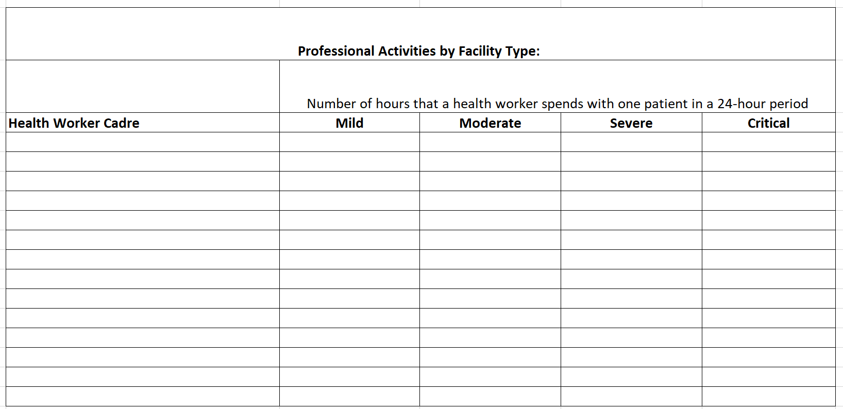

Staffing Data Collection Sheet

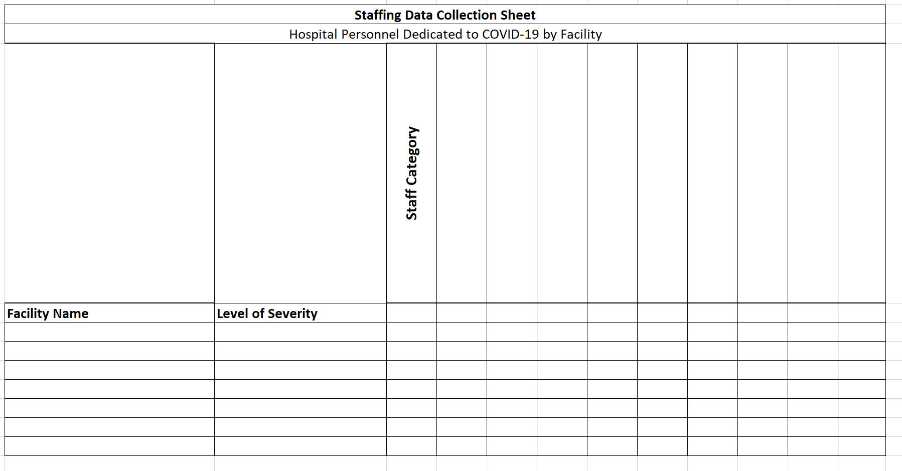

Available Working Time
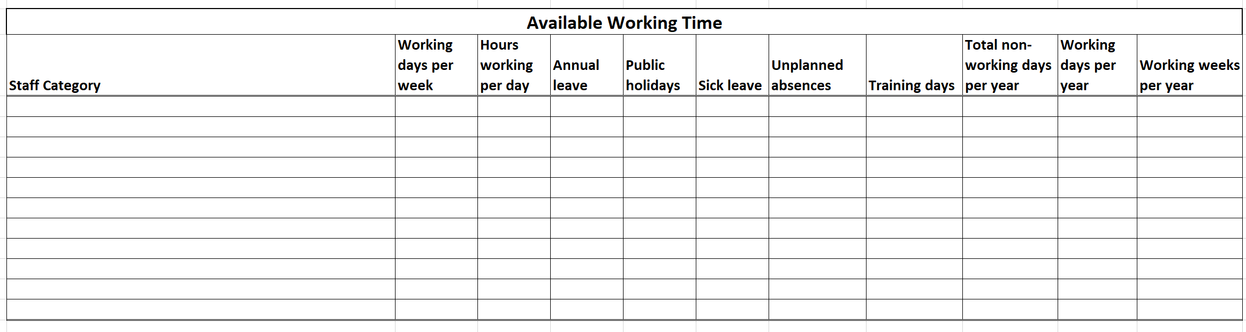

Facility Data Collection Sheets
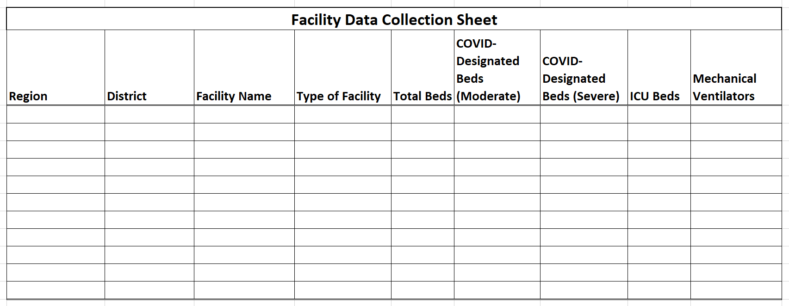

COVID-19 Daily Reported Data
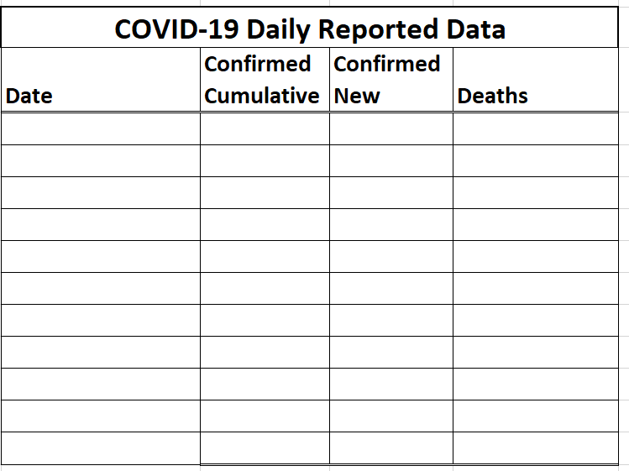

Role Substitution Data Collection Sheets (optional)
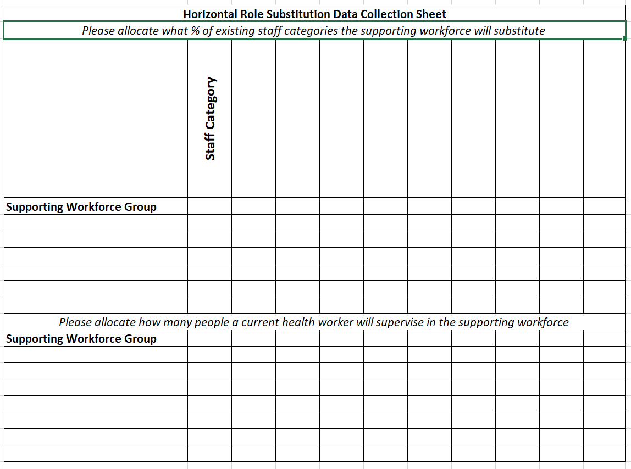
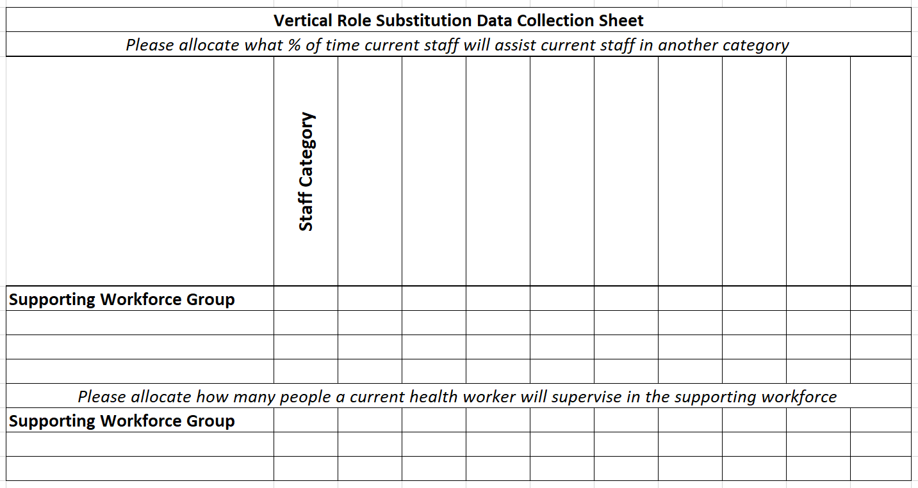

Midnight Census (optional)
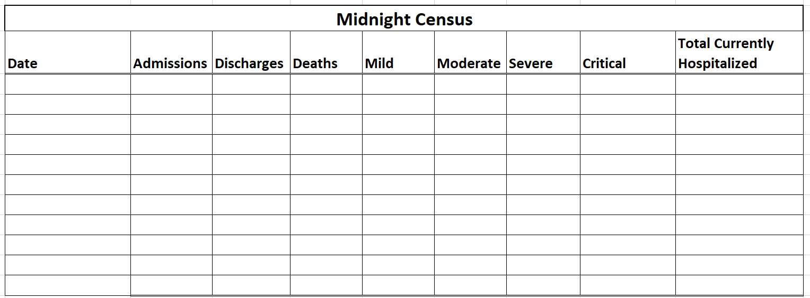

Annex 2. Time required per 24-hour day for professional activities by cadre and level of severity

HCWFE Mild Patient Needs
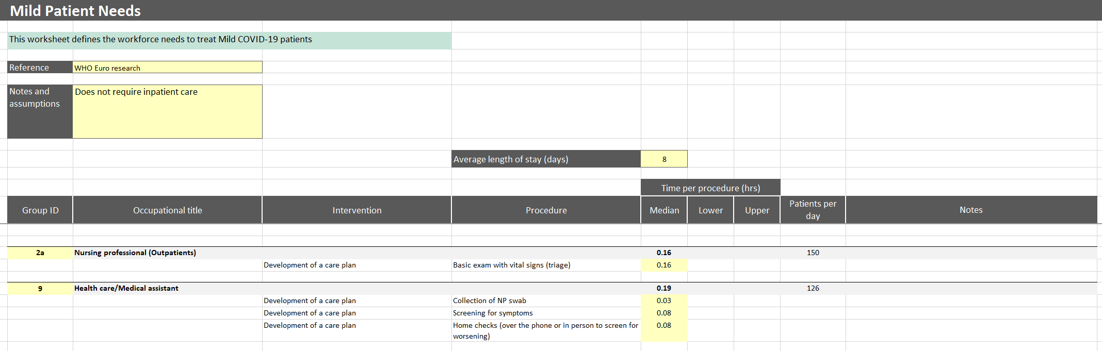
Note: the Mild Patient Needs tab of the HWFE defines the amount of time it takes to perform professional activities to care for a mild COVID-19 patient in a European context. You will need to reference this worksheet when defining your own professional activities, but the activities and times will vary depending on local context. It is important to document your assumptions.

HWFE Moderate Patient Needs
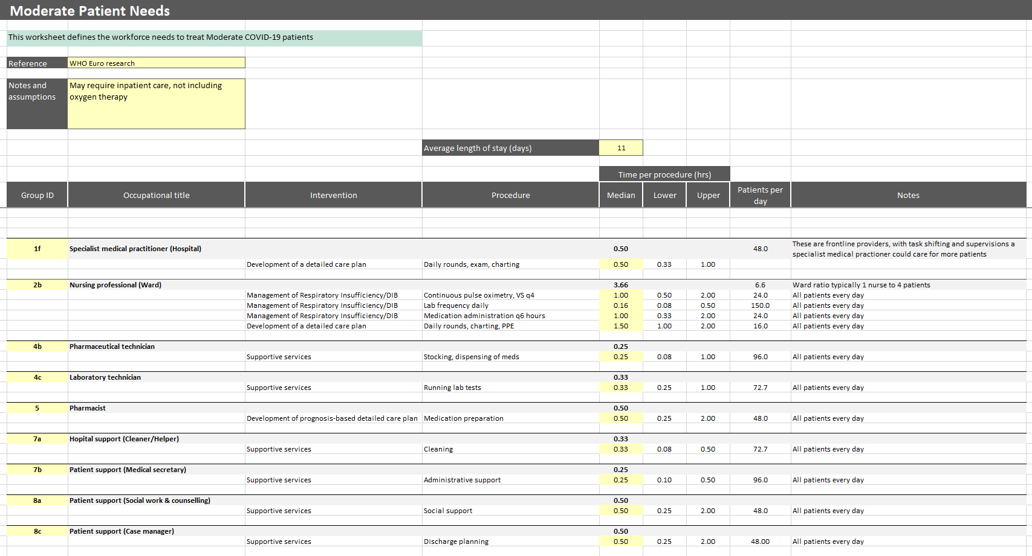
Note: the Moderate Patient Needs tab of the HWFE defines the amount of time it takes to perform professional activities to care for a moderate COVID-19 patient in a European context. You will need to reference this worksheet when defining your own professional activities, but the activities and times will vary depending on local context. It is important to document your assumptions.

HWFE Severe Patient Needs
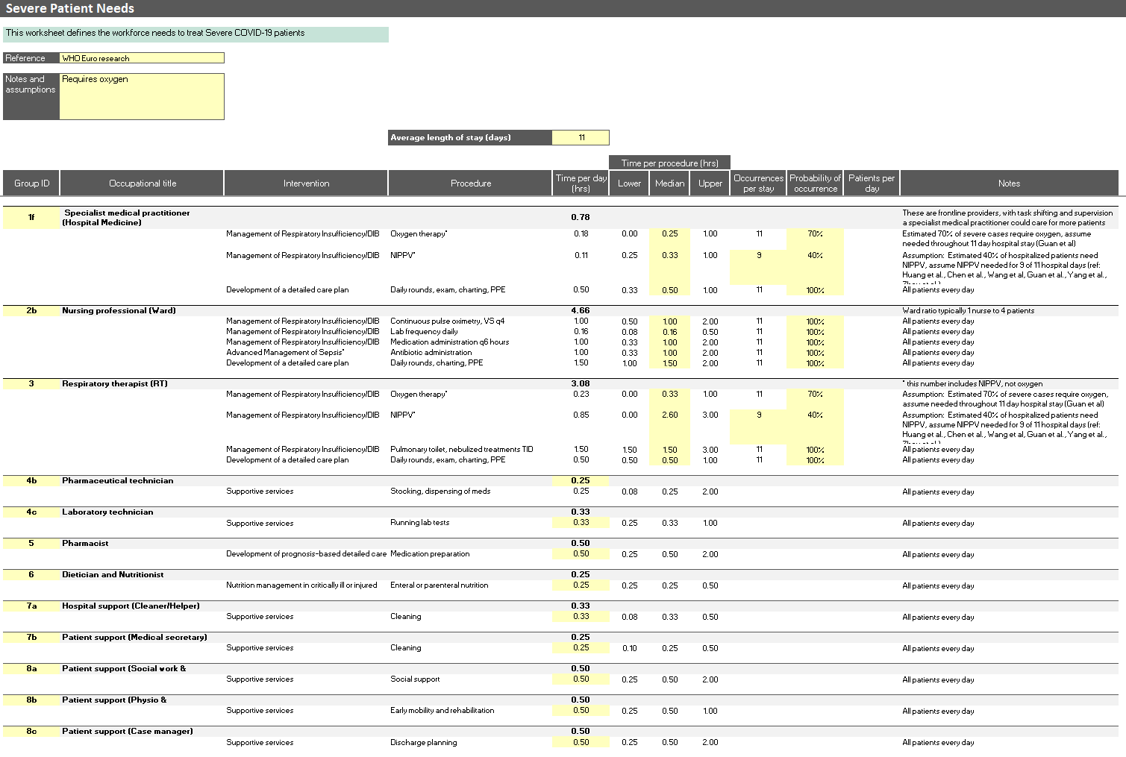
Note: the Severe Patient Needs tab of the HWFE defines the amount of time it takes to perform professional activities to care for a severe COVID-19 patient in a European context. You will need to reference this worksheet when defining your own professional activities, but the activities and times will vary depending on local context. It is important to document your assumptions.

HWFE Critical Patient Needs
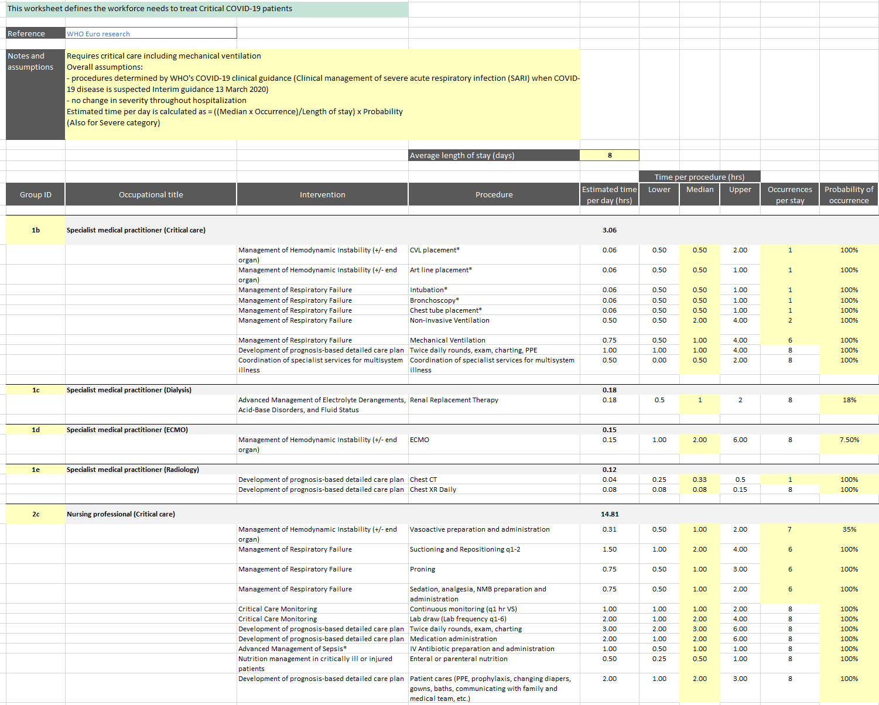
Note: this is the first half of the Critical Patient Needs tab of the HWFE (the rest of the sheet is continued on the following page). This tab defines the amount of time it takes to perform professional activities to care for a critical COVID-19 patient in a European context. You will need to reference this worksheet when defining your own professional activities, but the activities and times will vary depending on local context. It is important to document your assumptions.

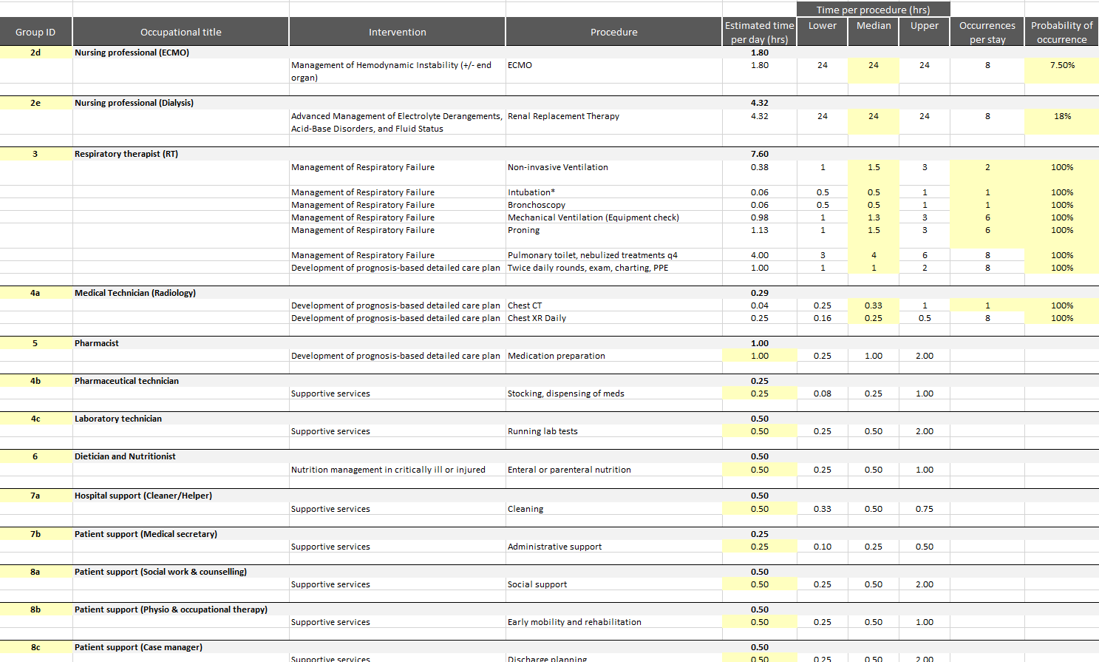
Note: this is the second half of the Critical Patient Needs tab of the HWFE. This tab defines the amount of time it takes to perform professional activities to care for a critical COVID-19 patient in a European context. You will need to reference this worksheet when defining your own professional activities, but the activities and times will vary depending on local context. It is important to document your assumptions.

